

Electrical Prober — Full GUI Manual

Table of Contents
Right-click here and choose ‘Update Field’ to build the table of contents.

Color key: dark green = top-level system (Accretech / Electroglas / NanoZ) • red = a major tab within that system • plain black = a sub-feature within a tab, matching the same colors used on the section headings below.

Introduction and Goals
Overview of Structure
Basics/Requirements
Accretech
Main
Top Bar
Side Bar
Internal
ATA Folder Browser
Copy / Delete Recipes, Wafer Maps, Probe Cards
Wafer Builder
Accr Wafer
Shot Template
Shot Map
Die Map
Overlay
Import / Export (CSV, Legacy PMA/Workbook)
Probe Card
Custom Pad Layout
Recipe
Fields
Touchdowns
Run
Wafer Map / Die Selection
Manual Move Controls
Start / Stop / Abort
Results
Results Table
Selected Die Table
Pass/Fail Summary
Export Formats
Database
Export Path / Lot ID
Importing Data
Cassette
Slot List (Add / Edit / Remove)
Arm / Disarm Automation
Lot Complete Summary
Debug
Instruments
SMU
DMM
Wave Generator
Connection / Address Setup
Switch Routing
Setup
Add / Rename Prober Bench
Add / Edit / Remove Instrument Slot
GDS Parser
Open / Parse GDS File
Export ATA Files (New vs Merge)
Export Log
Metadata Import
Switch Settings
Slot Configuration
Row Wiring / Roles
Prober Debug
Motion Commands (A/S/J/I/Z/D)
Raw Command Console
STB / Status Polling
GPIB Trace
Nanoz Switch
Electroglas
Main
Internal
Wafer Builder
Shot
Shot Map
Die Map
Import / Export
Run
Wafer Map / Die Selection
Set Initial Chuck Position
Move Mode
Start / Stop / Abort
Results
Recipe
Touchdown List
Validate Recipe
Probe Card
PMA Process
Load PMA / Recipe Generator File
Debug
Instruments
DMM — HP 3458A
Power Supply
Connection / Address Setup
Setup
GDS Parser
Switch Settings
Prober Debug
Jog Controls (Theta/Z)
Infer Die Size
Raw Command Console
GPIB Trace
Nanoz Switch
NanoZ
Setup
Discover / Connect / Disconnect Boards
Board Assignment
Board Assignment
Recipe
Overview
Named Recipes (New / Rename / Save / Load / Delete)
Shot List
Run
Charts
Results
Export Raw Results
Save Results CSV
Cassette
NanoZ_EK
Sequence Read / Write
EEPROM Access
Heater / Sensor Fields
Prober Debug

Introduction and Goals
This software is used to facilitate automation of electrical probing with the Accretech UF200R and Electroglas 2001CXE probers. It allows for integration with legacy programs and data uploaders. The main goal is to transfer the process flow from labview to python, as well as allow for compatibility with modern Windows OS versions.
The goal is also to make the machinery more transparent and user friendly. This manual also serves the purpose to help troubleshoot issues that inevitably arise from GPIB communication and usage of switchboxes.

Overview of Structure
All source code can be found in github:
All ATA folders and GUI system folder can be found in github:
For the executable, its internal memory of settings and wafer maps and programs are loaded in what is called an “ATA folder” (folder ending with “ata”). The default working directory (\\prober\M\ETL\proberautomation) has been hardcoded into the system and should have some already, you can pick from the top dropdown or load a specific folder using the button if not found. After loading, you will see what was found (and auto loads into other tabs). The GUI allows to edit and save to ATA, user should never have to directly edit a csv inside the folder.
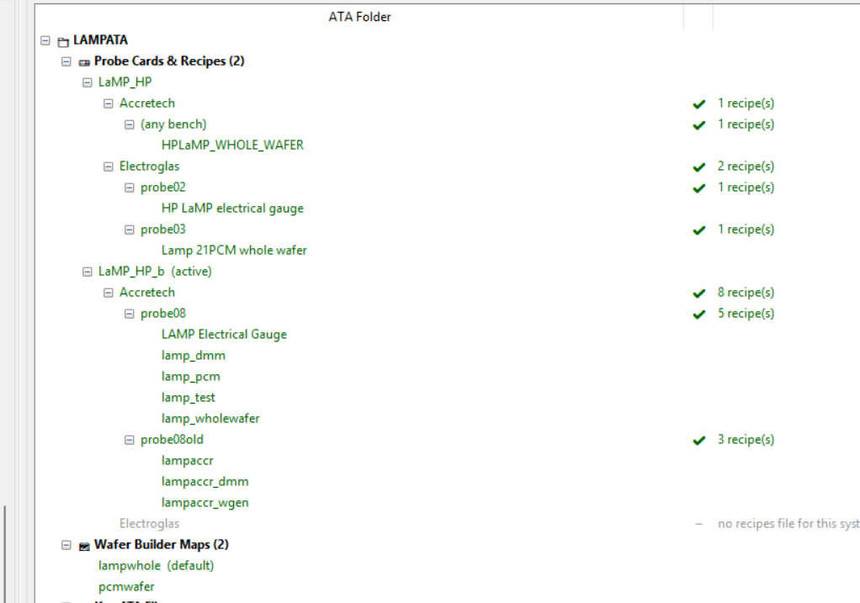
An example of the structure is as shown, most files in ata folders are in the form of a simple csv file. This means that it is easily editable directly if needed, all the GUI does is parse these files to extract recipe info, wafer maps, etc. As a result, nothing is stored on the local computer, since different computers would use the same working directory, its a shared memory. This also means that editing a project on one computer will sync on other computers (unless of course they use a different working directory). Keeping a backup is recommended and if the ata folders and gui system folder is lost, the github does hold a copy.

Basics/Requirements
If you just want to deploy on a new pc, this is the bare minimum to get started.
The PC doesn’t need to have python installed; however, to communicate through GPIB, the software uses pyvisa which relies National Instruments visa driver (located on NI MAX). For more details, check the operation and tips manual. The OS can be Windows 10 or 11 (for different OS systems, just verify python source code works), however if using Windows 11, verify its the correct GPIB cable.
To start, copy the executable to the computer (any folder is fine), set the working directory if default doesn’t work (and if ATA folders are gone, copy over the backups from github), and it should launch and load all the recipes (ie. lamp, maddy, cenfire); otherwise just start from blank slate and go to recipe creation.

Accretech
The full operation of Accretech is in its own manual. Main thing to note is that most commands cannot be sent to prober unless it is in the “Probing” state, which is when wafer and probe card is already loaded and pins are ready to touch. Furthermore, the Accretech has its own internal wafer map, with its own rows and columns and coordinate system. It also doesn’t keep track of die ids and is not connected to the electrical equipment or probe card directly. For Accretech, before using the software, you need to train a wafer on the internal setup and create a device data file, then also figure out the probe card wiring, figure out whether it is direct connection or using switchbox, and which of the 24 pins are being used if using switchbox. Only then can you start creating a recipe on the software.

Main
As you launch into the software, you will see two overarching sections Main and Debug.
Debug should not be needed for normal operation, Main section will hold everything needed for probing a project from start to finish.
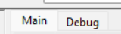
The main section has these tabs:

Top Bar
On the far right, you can use the toggle to make sure it is on Accretech (yellow is selected).
The ATA folder dropdown shows list of available ATA folders found in the working directory. Click the field to load an ATA folder.
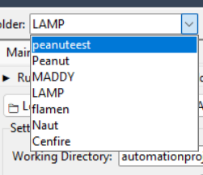
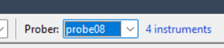
The prober dropdown holds probe setups. Right now it should be only probe08, but if instruments change or if this software would be liked to be used for other Accretech probers, you can add more in the setup tab.
The Abort button sends a K command to the Accretech, while Buzzer clear sends an es command. es can be used at any time, but not recommended, just clear from the actual prober screen itself. However, the abort button is useful to exit the “Probing” screen or stopping a run.

Side Bar
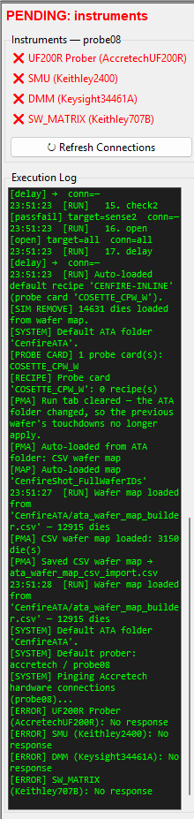
This side bar has two sections, the instruments and the log.
The instruments will change if you switch the prober bench that is currently selected.
If red, the gui attempted to ping, but didn’t find it. If green, it pinged at startup and was connected then (doesn’t actively check afterward). If yellow, it is pinging. Press refresh connections to ping again. Remember that if instruments are connected, such as DMM or SMU, it will be in remote mode, and the buttons on the equipment won’t work manually (unless the remote mode is released). Also remember, that this ping process is just through gpib or usb, but it depends on the pyvisa driver working.
The log will show what loads, recipe steps, and live run information, etc. It can be helpful for debugging, and making sure runs are successful and data export works.

Internal
Starting with the internal tab, this is a good tab to start with to set up working directories and verify loading of ATA folders.
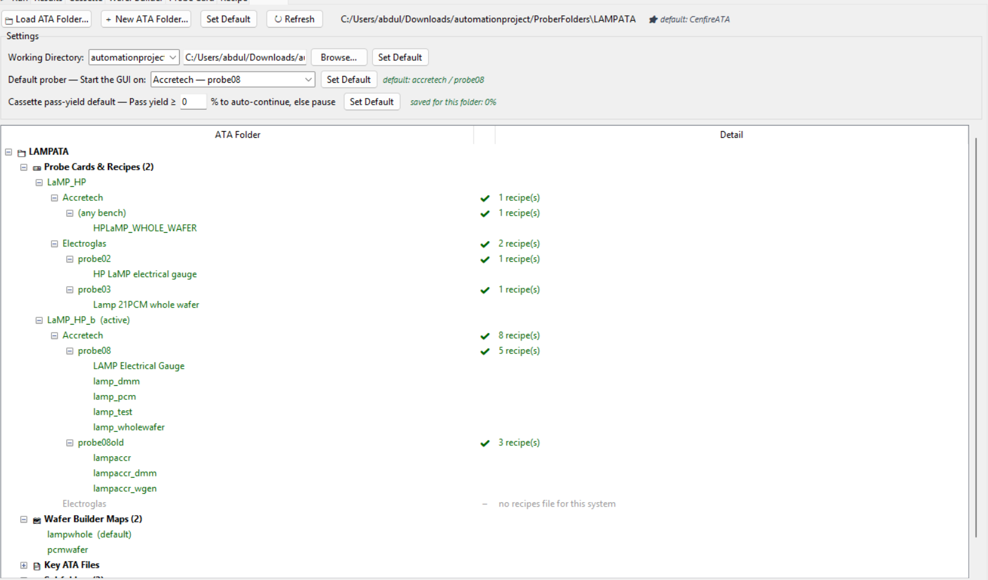
Starting from the top, load ata folder button will allow you to browse pc to load a specific ata folder, but this is not recommended to use, just set a working directory and have it autoload those.
New ATA folder button, however, is a useful button. This is the first thing to press when starting a new project (a new wafer type).
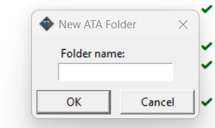
After clicking you can set a name for the folder. Once done, this will create a blank folder in the working directory (using that name appended with ATA at the end). Press refresh and verify it appears in the top dropdown of the ATA folder.
Once a folder is loaded, you can press Set Default to make sure that it will auto load whenever the software is opened. This default setting is saved in the GUI System folder; in fact, this information is saved on the shared Gui System folder, but it can be different for pc to pc. What I did is that I assigned a default per PC name in a csv file (along with every other set default button that will come up).
The Refresh button is important. If changes happen, or if any changes are made to the files (ie copied recipes, deleted recipes) in the internal tab, you will need to press refresh for changes to show up (or you can just close and reopen software, which will just trigger the load again anyway).
Working directory has a dropdown with some presets hardcoded in. Proberautomation is the one you should be using, but if things are changed, I recommend to just go into the code and change the presets. You can also press browse to open the file explorer and pick a directory yourself. To save it, you can press the Set Default button and it will remember this directory by saving it in a working directory json file in the same folder the executable is stored in. This is the only file that is not stored in the proberautomation folder, and will just be with the executable. If accidentally deleted, it will just recreate the file every time set Default is pressed.
Default prober will allow you to set default, this setting is stored in gui system folder. Example: If you set default as probe08, it will autoload into Accretech, if you load probe03, it will autoload into electroglas. This is how you can set which system at startup.
Cassette pass yield is for cassette automation. I kept at 0, but it is recommended to put at a reasonable percentage to mitigate risks. What it will do is pause the cassette automation if too many dies fail the recipe conditions. This may be useful to stop too many wafers from being probed if for any reason the equipment has broken down. You can also set this value on the cassette tab itself. This value is ata folder specific.

ATA Folder Browser
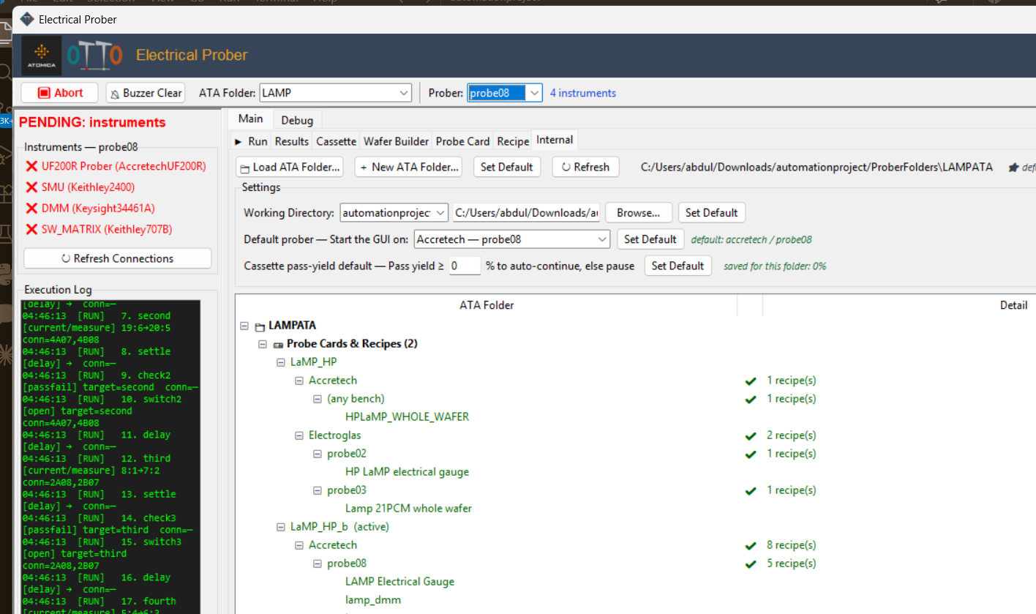
Below the working directory/default prober/cassette-yield settings, the rest of the Internal tab is one tree view of everything the loaded ATA folder actually contains. You can go through the key files, and just see what was found, and how they are separated between probers and systems (because recipes are system specific).
“Probe Cards & Recipes” and “Wafer builder maps” are the sections you can directly edit from here. Each probe card name is a top-level branch (the one marked “(active)” is whichever card is currently selected on the Probe Card tab). Under each card, it splits by system (Accretech / Electroglas), then by bench (e.g. probe08, probe02, probe03, or “(any bench)” for a recipe that isn’t bench-specific), then lists the actual recipe names as the leaves. A green check mark and a recipe count at any level just means a recipes file was found there – it is not a guarantee every recipe in it loads cleanly, only that the file exists. If a system has no recipes file at all for that card, you’ll see a dash and “no recipes file for this system” instead of a count, which is exactly the gap this tree was built to surface.
Further down (not shown in the screenshot above) the same tree also lists “Wafer Builder Maps” – one entry per saved map, with “(default)” marking whichever one auto-loads for this system – followed by a collapsed “Key ATA Files” section (the handful of core files the software expects, each shown as present/missing, which doesn’t mean it is necessary though) and a “Subfolders” section listing anything else sitting in the folder root.

Copy / Delete Recipes, Wafer Maps, Probe Cards
Right-click any recipe, wafer map, or probe card row in the tree above (not the folder/section headers – only rows that are actually a recipe, a wafer map, or a probe card) to get a small menu with a Copy and a Delete option for that item.
Copy opens a small dialog to pick a destination – for a recipe that means a target probe card, system, and bench, plus a name for the copy; for a wafer map or probe card it just asks for a new name. This is the normal way to reuse a recipe across probe cards or benches without rebuilding it by hand.
Delete asks for a yes/no confirmation naming exactly what you’re about to remove, then deletes it and refreshes the tree. There is no undo – if you need it back, it has to come from a backup or from another computer that hasn’t pulled the change yet (see the note on shared working directories at the start of this manual).
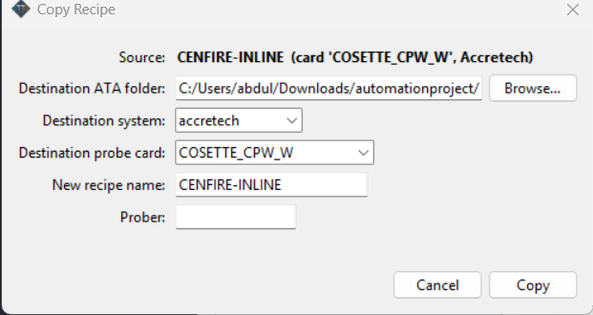
You can attempt to copy recipes for other systems, but you should verify that the steps actually make sense if you do.
If you copy or delete on this tab, remember to press refresh button, or relaunch the software.

Wafer Builder
Wafer Builder is where you describe the wafer’s die layout from scratch (or import one) when you don’t already have it from elsewhere. No matter the system or project, you need to use this tab to some extent to start. It works in five steps for Accretech, one per sub-tab: Accr Wafer (extracting initial map), Shot (what one touchdown physically covers), Shot Map (how many touchdowns and where, across the whole wafer), Die Map (the whole wafer at individual-die resolution, computed from the first two, where you actually name dies or mark them skip/align), and Overlay (where you can join the Accr and Die Maps).
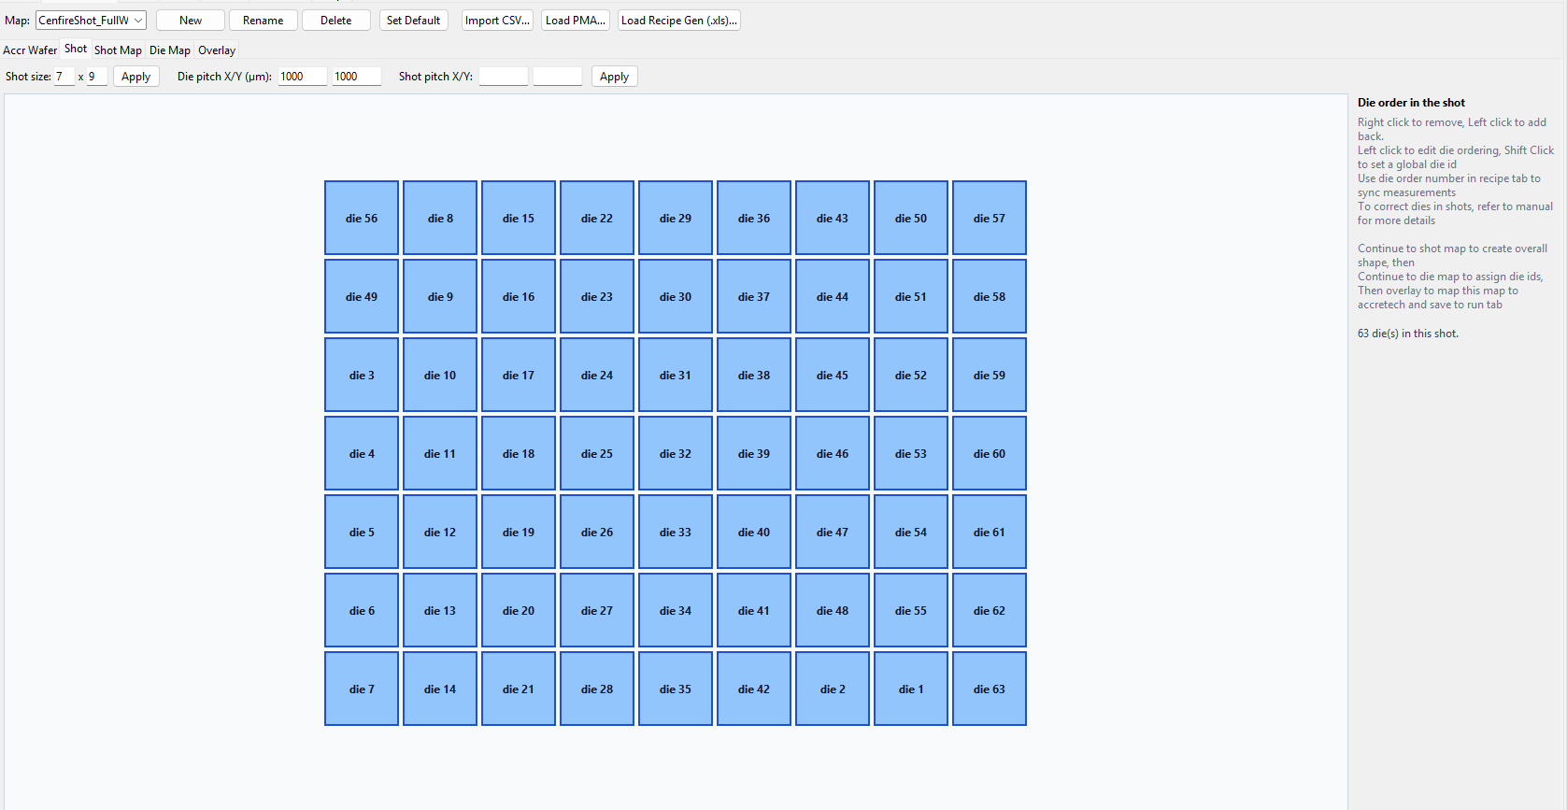
The toolbar at the top is shared across all three sub-tabs: a Map dropdown to pick which saved map you’re editing, New / Rename / Delete / Set Default to manage saved maps the same way the Probe Card and Recipe tabs do, and Import CSV… / Load PMA… / Load Recipe Gen (.xls)… to build a map from an existing file instead of by hand (see Import / Export below).

Accr Wafer
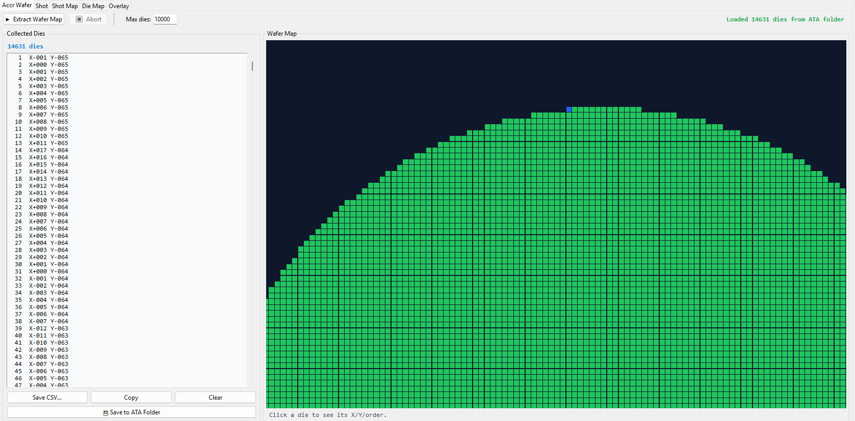
To start with Accretech, first train the device data and create the wafer map on the prober itself (see Accretech operation manual). Once done, you will need to extract it. A wafer needs to be loaded on the prober (probe card not needed and will not touchdown, but of course prober does require it) and in “Probing” state. Then, click extract wafer map, and the software will iterate through the entire wafer one by one and figure out the rows and columns for each die, how many dies total, etc. Once done, you will have to save to ATA folder on the bottom. Thats it, the two buttons that are important are just extract wafer map and save to ata folder, and then you can move on.
However, you may abort if you would like to cut it short. You can save a raw csv of the table, copy the data, clear the data, but not useful to this software otherwise. You can set max dies to be larger if needed. Also, Accretech does actually have a usb port to grab device data if you wanted to back up, for future work, it may be helpful to see if device data can be parsed in different ways. Right now, all this software does is just send J command to move and Q command to find current xy coordinates, and then note them down.

Shot Template
A shot (or field) is the area that is measured in one instance. Some probe cards have pins for more than one die at a time, for example lamp measures 4 cards at once. Others have pins for only one die, but does not measure all dies, only certain ones in a certain shot. As a result, this is project specific, and choosing a shot size is extremely important and can be helpful to tinker around with this setting.
The Shot tab defines a single touchdown as a small grid: Shot size (rows x cols) plus Apply sets the grid dimensions, and Die pitch X/Y (µm) sets the real physical spacing between dies inside it. Shot pitch X/Y is a separate, optional spacing used only for laying touchdowns out on screen elsewhere in Wafer Builder — leave it blank and it defaults to the shot’s own footprint (cols × die pitch X, rows × die pitch Y). Setting the die pitch for Accretech does NOT affect actual operation. It only changes the size of squares on the wafer map so that it can reflect the real visual grid (computes length vs width ratio to draw the rectangle), and also serves mostly as a way to store this info as reference.
Click a square in the grid to add it back if it’s empty, or to set its die order (which die – 1, 2, 3…– it is within the shot; this is what the Recipe tab’s Die # field and the Results tab use to know which square a measurement belongs to, it is not a pin/relay assignment). Right-click a square to remove it from the shot entirely (for a shot that isn’t a full rectangle). Shift-click a square to give that slot a die ID that applies to every shot at that same position across the whole wafer — an individual die can still override this later on the Die Map tab. The status line below the grid shows how many dies are in the shot and how many slots have a name set.
To reiterate, you don’t need to name die ids here yet, however, it is helpful to tinker around with die ordering, and naming to make it easier to setup the whole wafer map. Die order is especially important, because when recipe is created, measurements will be assigned to die numbers. The software and prober has no way of telling where on the xy position in a shot the die is actually located, so it is all up to you as the operator to define it, so that the final wafer map and measurements map data to the correct squares.
In this example picture, you can see that I labeled die 1 and die 2 near the bottom for the Cenfire project. The cenfire project had a large shot of 7 by 9, but the probe card only measured two dies per shot. As a result, I am able to tell the software which two on the shot I actually want the data to be assigned to.
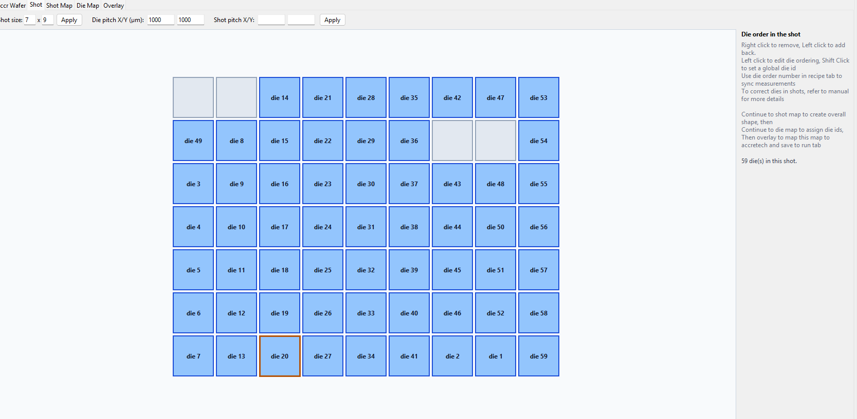

Shot Map
The Shot Map tab is one square per shot, laid out across the whole wafer — Wafer size (rows x touchdowns cols) plus Apply sets how many touchdown positions exist, and clicking a square toggles whether a touchdown actually happens there. ☑ Fill All fills every square at once (it turns into ☐ Clear All once everything is already filled, so the same button does both). Row/column index numbers along the left and top edges make it easy to read off a specific touchdown’s position. The status line shows how many touchdowns are currently on.
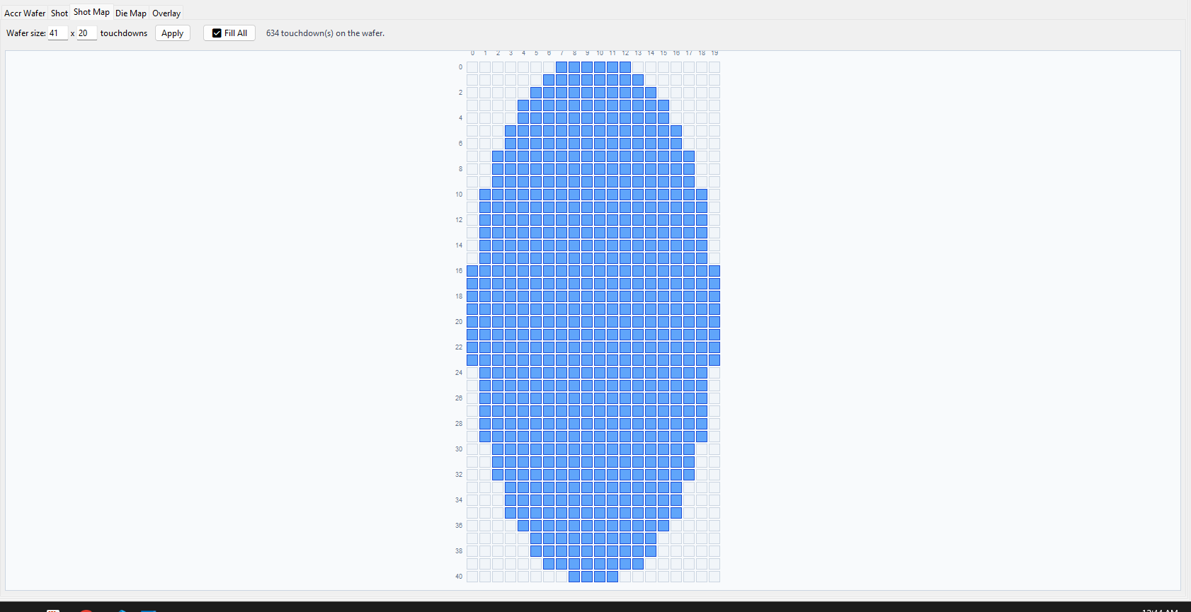
Here, this helps to set up the full wafer map. Once applied, the die map will take info from the previous two tabs. As an example, for lamp which is a 2 by 2 shot, and then, with a 41 by 20 shot map with 634 shots, the actual die map will be a total of 2536 dies.
(Note, that if you import csv, this shot map tab may not reflect or might be skipped. As long as die map looks correct, this tab is not important it is an intermediary step. Just remember that if you press apply, it will overwrite die map tab though.)

Die Map
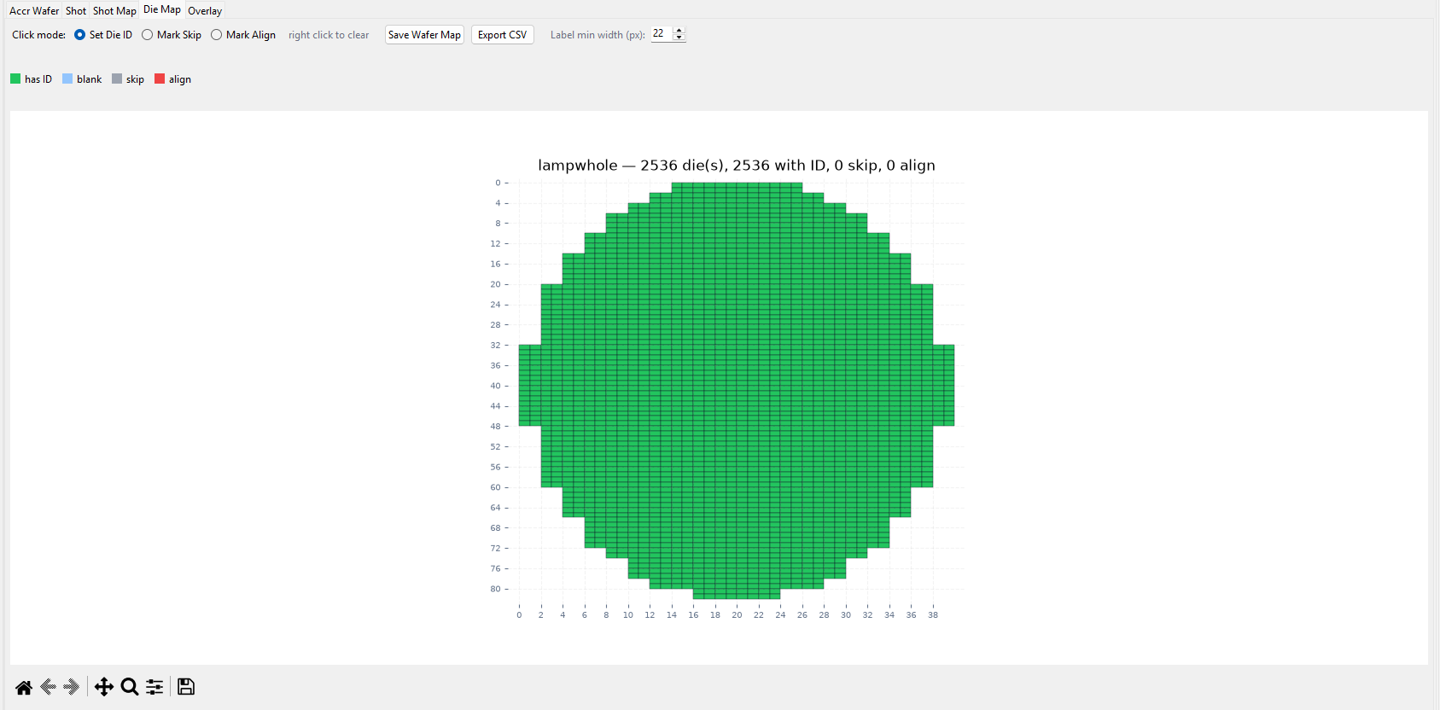
Die Map is the payoff of the previous two tabs — every die the current Shot × Shot Map combination produces, drawn at full wafer resolution and colored by status (see the legend: has ID / blank / skip / align). Click mode picks what clicking a die does: Set Die ID prompts for that one die’s ID (overriding whatever the Shot tab’s slot-level name would otherwise supply), Mark Skip flags it to be left out of the recipe entirely, and Mark Align flags it as an alignment/PCM/target die rather than a real device — right-click any die to clear whatever’s set on it, regardless of which mode is active. Align flag does not affect operation, but will help visually if needed.
Save Wafer Map writes the current map under whatever name is selected in the toolbar’s Map dropdown. Export CSV writes it out as a plain CSV instead/as well, for use outside the GUI. Label min width (px) controls how zoomed-in you need to be before die-ID text actually renders on the map — the same control also drives label visibility on the Run tab’s own wafer map, so changing it here affects both.
To edit die ids, you will need to click on a square, and type text. You are not required to label all dies, though it does help a lot to label at least one die that you can use for alignment and just sanity check while running. For the wafer map here, you will need to zoom in (scroll wheel or buttons on the bottom bar) to see die ids to be rendered. If you zoom out again, they will disappear, but are still there. This zoom in/out die id feature does extend to the other tabs as well. In this tab, the shots are not visually separated, but still are defined. Once done, move onto Overlay. 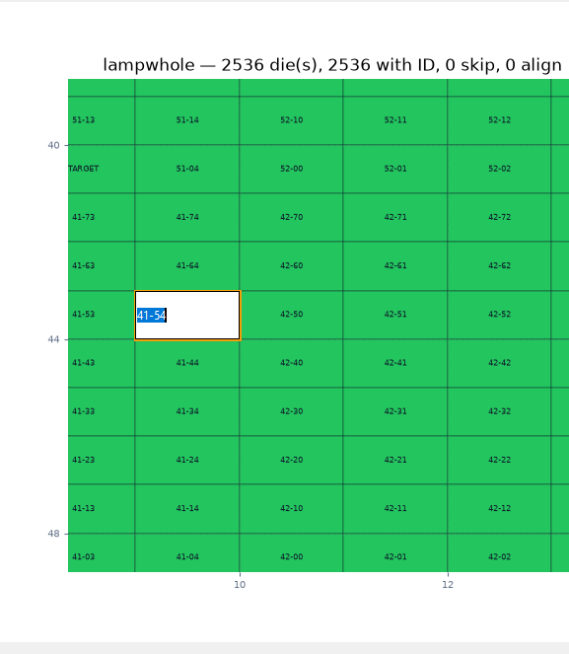

Overlay
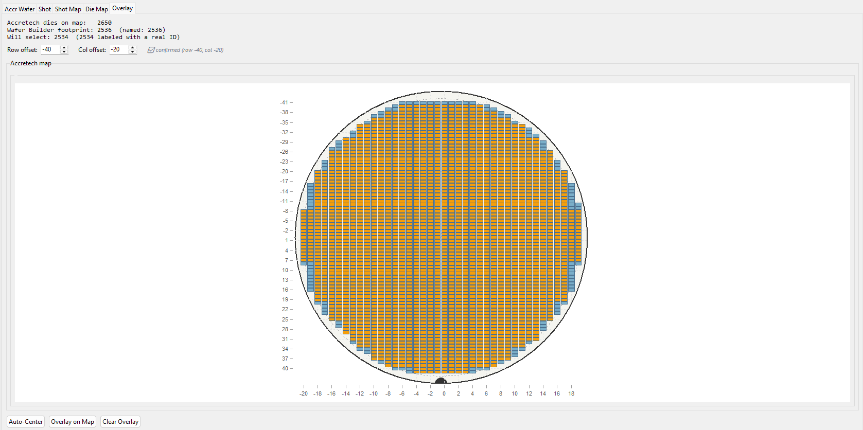
Overlay Alignment (Accretech only) lines up a Wafer Builder map against the Accretech prober’s own internal wafer map, since the two don’t share row/column numbering on their own. A summary line reports how many dies the Accretech map currently has, how many the Wafer Builder footprint covers (and how many of those are named), and how many will actually get selected once matched. Row offset / Col offset shift the Wafer Builder grid against the Accretech one — Auto-Center computes a starting offset for you from both grids’ centroids rather than guessing by hand.
Overlay on Map commits the current offset — it selects the matched dies on the Accretech map (visible in the preview below) and is what actually makes this mapping take effect for the Run tab. Clear Overlay removes it. The preview map underneath behaves like any other wafer map here (scroll to zoom, drag to pan) so you can visually confirm die IDs are landing where you expect before committing.
What I recommend for figuring out what overlay to use, is to overlay first, then go to run tab and select a die id that is known and moving to it. Then look under the camera of the Accretech prober and see if the wafer actually was landed there. If not, figure out how far away it is and fix the offset. Once Overlay on Map is pressed, it will be saved and the software will remember the wafer builder map for that ATA folder.

Import / Export (CSV, Legacy PMA/Workbook)
Now, if a csv of the wafer map already exists, you can attempt to shorten the process by importing it.
Import CSV… builds a Wafer Builder map from a plain CSV of die positions/IDs instead of clicking through Shot/Shot Map/Die Map by hand — dies whose ID looks like an alignment/PCM/target die (by keyword, or by not matching the shape of the wafer’s other IDs) are automatically marked align rather than imported as an ordinary numbered die.
Load PMA… and Load Recipe Gen (.xls)… do the same auto-fill from a legacy Electroglas .PMA file or an old Recipe Generator .xls workbook respectively — both only ever populate this tab’s own Shot/Shot Map/Die Map state, they don’t touch anything on the PMA Process tab (Electroglas’s separate .PMA loading there also feeds the Run tab directly, which these two do not).
Export CSV, on the Die Map tab, is the export half — write the current map back out as a plain CSV for use outside the GUI or as a starting point to hand-edit and re-import.
I would highly recommend to verify the results once you press import, the software can only go so far to try and parse a csv file without a set reference to go off of. Also, you still need to do the Accr Wafer and Overlay steps, there is no shortcut for those currently.

Probe Card
This tab defines the physical probe card currently in use — what pins actually exist on the probe card and how they map to the 24 switch connections. Note: that is the main and only thing you need to define, the rest is for reference and notes.
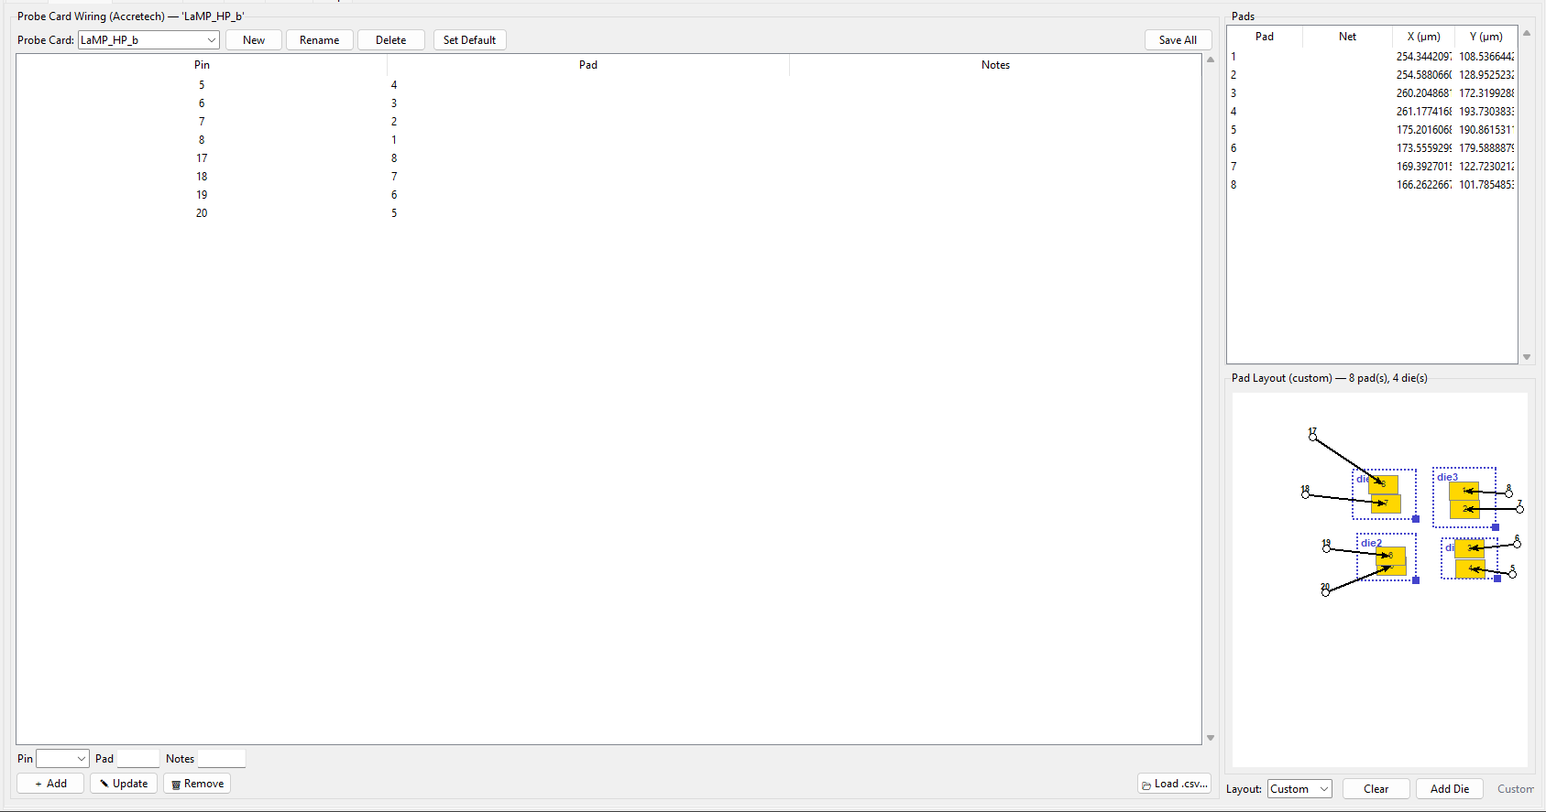
The Probe Card: dropdown at the top picks which saved card you’re editing. New / Rename / Delete manage cards by name; Set Default marks the current one to auto-load for this ATA folder on this system (Accretech and Electroglas each get their own default, since a card wired with one system’s pin format isn’t necessarily valid on the other). Save All writes everything on this whole tab — pin wiring and the Custom pad sketch both — in one press.
The table lists every pin/pad/notes row wired on the card so far. Select a row to load it into the Pin / Pad / Notes fields below for editing; the Pin dropdown there only offers pins actually wired on the active bench (which is 24 for Accretech, it re-checks Switch Settings live, so widening the switch matrix there is picked up immediately, with nothing to keep in sync by hand). ＋ Add adds a new row from those fields, Update overwrites the selected row with them, and Remove deletes the selected row. 📂 Load .csv… imports wiring from a CSV instead of entering it by hand, and expects a simple three column file.
To reiterate again, the only thing that is required is for you to fill in is the Pin column to define which pins should be available for the recipe tab to use. It is recommended to fill in a Pad or notes for yourself to label what the name of that pin is or what connector it is (ie. J25, Top Left, etc.)

Custom Pad Layout
The pads and pad layout is entirely for reference, it is a good way to sketch out and plan how you want to test.
The Pads list (top right) shows every pad on the current card — name, net, and X/Y position in microns. What feeds it depends on the Layout dropdown below the sketch: ATA reads real pad positions out of the ATA folder’s own data for this card; Custom is a layout you sketch by hand instead, for a card that doesn’t have real coordinates available yet.
Clear deletes every pad and die in the hand-drawn layout (confirmation prompt first — there’s no undo), and Add Die adds a new die shape to the sketch to place and wire up. The custom sketch is saved by the same Save All button at the top of the tab, not a separate save of its own — Clear and Add Die are disabled whenever Layout is set to ATA, since there’s nothing hand-drawn to edit there.
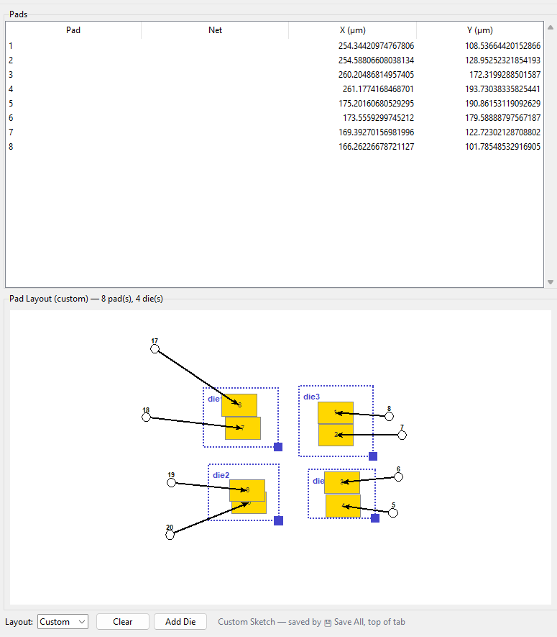
Play around with the sketch functionality, there is no risk of messing up operation with this. The arrows will put the pin number on one side and the arrow will point to the pad as shown by the pad column on the table.

Recipe
This is where the actual test sequence and measurement configurations gets built, and you will need to take a lot of care to setup correctly here.
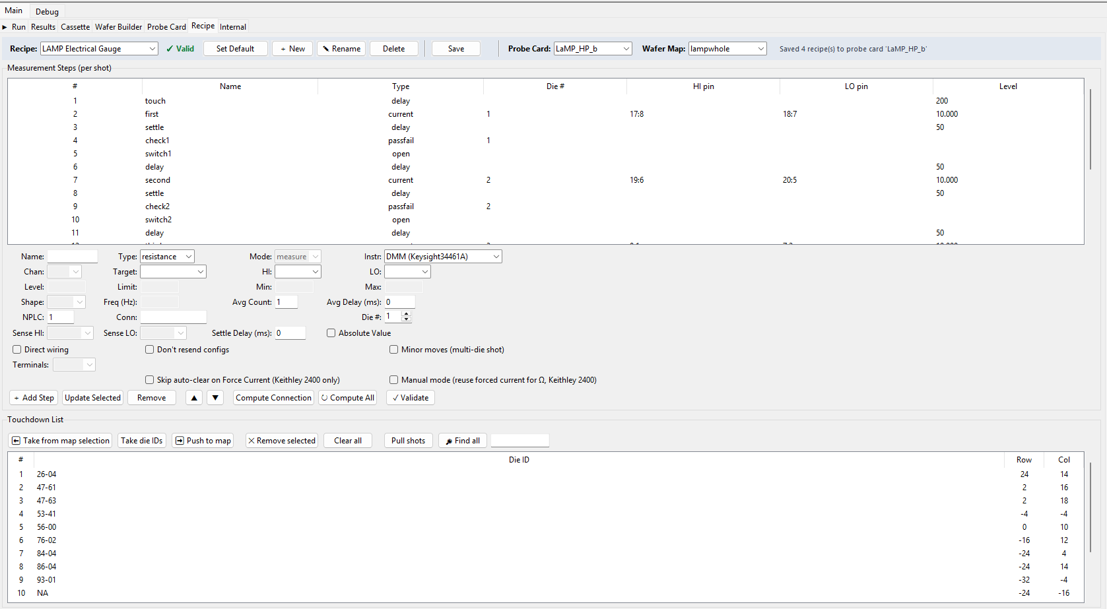
Starting with Recipe dropdown at the top (with New/Rename/Delete/Set Default/Save alongside it) picks which saved recipe you’re editing, and it’s always tied to whichever Probe Card is selected next to it — switching the probe card switches which recipes are available. Assign wafer maps to each recipe as well, so it will autoload the correct map. To reiterate, recipes are per probe card basis, but recipes also need to know what wafer map to load as well, look at internal tab for more clarification on the tree structure.
Set default will save this setting in the ATA folder, so each ATA folder can have its own default recipe that it will autoload (in the run tab also). Setting default will automatically load the correct probe card also. Below that: a Touchdown List (which dies get probed) and a Measurement Steps table (what happens at each one), each with its own toolbar.

Fields
Picture does not work yet, if someday a prober has the functionality, it can be coded in. Move only appears in the Type list once this recipe’s own Minor moves (multi-die shot) checkbox is on, since it repositions the chuck to a specific die within the current shot and is meaningless without that shot geometry.
Now, going deeper into each field one by one.
Name is simple, it will name the step so that it is easier to navigate the table. \
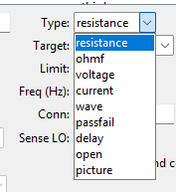
A step's type is one of: resistance, ohmf (4-wire resistance, with separate SnsHI/SnsLO sense pins), voltage, current, wave (waveform generator), passfail, delay, open, picture (not implemented), or move. Resistance will be a 2 wire, ohmf will be 4 wire. Delay will use millisecond as the unit, you should use this step often to allow for settling timing. Open is extremely important, it refers to the switch matrix crosspoint connections. Passfail allows to set a range that a measurement needs to be in to set a die for pass or fail and color it so.
Mode (measure/apply) then says whether that step reads a value or only drives one — e.g. a voltage step can measure or apply, a resistance step only ever measures. However, if a step is set to measure, it can still bias at the same time as the measure step. For example, if you wanted to bias 10 volts on 2 pins and measure the current on those same pins with a compliance limit of 1 microamp (like Lamp electrical isolation shown below), you can set it as measure current, but put 10 in the level field (which automatically figures out voltage if you picked measure current, will do the reverse if you pick current). This means that power is still being supplied for a measure step. If you pick a step to be apply, it will not measure.
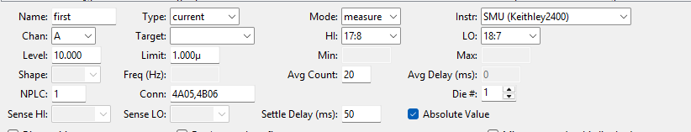
For Instr, it will allow you to choose which instrument to use. For the current Accretech setup, you only really need to choose between SMU or DMM. If you are biasing in any way, even in a measure step, you will need to use SMU. The model is shown, in case instruments have changed in setup tab and you should confirm it matches. (If you add more instruments in setup tab, confirm that it still works in code, drivers is not guaranteed to port over perfectly).
For Channel dropdown, it only really matters if the instrument has more than one channel such as the Keithley 2636B. Right now, Accretech does not have it, so leave it untouched, but for multi channel equipment it is important to set the channel.
Target is one that has multiple functionalities depending on the Type. If the type is a open step, it will allow you to pick which switch connections to open. If the type is pass fail, it will allow you to pick which measurement to apply the pass fail range to (for example, if the measurement from step 1 needs to be under 100 ohms, set target to step 1 for the pass fail step).
However, if the type is a current, voltage, or resistance, AND a measure type, then it will allow you to do a transform on the measurement data for that step. For example, if the measure step is voltage, you can pick a previous step in the target dropdown, and it will apply a transform on the voltage data that is received. The recommended example use case is that if you want to bias voltage on 2 pins, but read current on 2 other pins, and then compute something like resistance, you can use this functionality. It will figure out from the types to do the V/I ohms law transform, and then the data taken from that step will in Ohms. (Note, the step is still a voltage, but the data will be in ohms, this can be confusing in the results tab, so make sure you make this choice consciously, or you can do this transform outside of this GUI if it causes too much confusion).
HI/LO pins allow you to choose from a dropdown of the 24 pins of Accretech switch. It will only show the pins available for the probe card that is currently loaded. Furthermore, it will show the pad column after the pin number, so that pad can be used as labels to make it easier for you to remember which pin maps to what. For all measurement types, you should only need two pins per step, except for ohmf, since that is four wire. For ohmf type, you should also set the Sense HI and Sense LO pins accordingly.
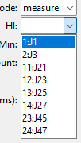
Level is another field that has different functionality depending on the type. If voltage apply, it is volts. If voltage measure, it will allow you bias amps. If current apply, it is amps. If current measure, it will allow you to bias volts (again leave it blank for no biasing). If delay step, it is the amount of time in milliseconds. If wave, it depends, but usually volts.
Limit is for compliance limit on the equipment. For example if applying 10 volts, you should set the compliance limit to some amount such as 1 microamp.
Note: for these two fields, you can actually use extra text modifiers after the numbers to signify units such as micro or milli or kilo, etc. such as p,n, u, m, k, M. You can also just tack the actual unit letter on with no effect on scale — 5V, 5A, 5Ω, 5s, 5H, 5F all parse as plain 5, so "5mA" works too (m = milli, A is just ignored). Whitespace between the number and suffix is fine either way.
Min and Max are for pass fail type. It allows you to set a range (you will also need to set a target on a previous measurement step with data) such that the die will be labeled red or green on the run tab. If you have multiple pass fail steps in a single recipe for a single die, it will be an AND operation, if one fails, the whole die is labeled fail. However, if you multiple pass fails for different dies in a shot, it should consider each die its own separate pass fail condition of course. (if bugged, code fixes may be needed). You can leave min or max blank, to have no lower or upper bound.
Shape and Freq is for wave type, to allow for the shape of the waveform.
Avg Count is an optional setting for a measure step, that allows that specific recipe step to repeat multiple times and then take all the measurement data from each iteration and then average them and then report a single number. However, some instruments actually do averaging internally, so Avg Count may just call the equipment specific command, worth debugging if unexpected results appear.
Avg Delay sets how much time to wait between iterations of the avg count repeated step, However, as mentioned before, some instruments do averaging internally, and so this field is not used.
Settle Delay is used for measure steps that use biasing, you can allow for some settling time (since you can’t put a delay if you measure in the same step as the bias).
NPLC is a instrument specific setting that allows to set an integration constant for the measurement. See project specifications for what to set this.
Conn: shows what switch connections to close for that step. You shouldn’t need to set this manually, you can use the compute connection or compute all buttons below to fill this out. What it does is that it takes the pins you selected for HI LO and the instrument, then it references the switch setup to see what row and column to close, then it will fill out this field. You can edit this field if you know what connection to use. REMEMBER to open all steps when applicable and open all connections no matter what at the end of the recipe anyway. (or else you risk shorting wires on switch).
Die # field is an important one if you have more than one die per shot. It will default to 1, but if you have four dies in a shot for example, and you want to measure every single one, you will need to define which step actually maps to which die. The equipment and pins and switch connections will still work if the die number is wrong, but the data may not be reported to the correct die id, and the pass fail may be bugged, and the green red coloring on the wafer map may not be accurate. So make sure, that each measure, apply, and pass fail steps have the correct die number. Remember, that the die number is defined in the wafer builder map tab, shot tab.
Absolute Value checkbox for a measure step allows you to take the data, and remove negative sign. If you enable this, the original data is not recoverable, it will report magnitude only. You can do this transform later, if you want to troubleshoot.
Direct Wiring is an important checkbox. If you are not using switchbox for a certain step (such as Peanut project or PCM test for lamp), then HI LO pins cannot be filled out obviously. To allow the software to know that the switch is not being used for this recipe, you need to enable direct wiring. If you enable, you can still have steps send commands to equipment, it will just skip switch connections.
Minor moves checkbox is another important one. If you have a shot with more than one die AND if the wafer needs to be moved in between dies in the same shot, then you need to enable. (For example, cenfire has a shot with two dies and needs to move in between. However Lamp has a shot with four dies, but does NOT need to move, so you shouldn’t enable minor moves for that one).
Don’t Resend Configs is a experimental setting that is not guaranteed to work for every project. The idea is that it will help cut time for the full run by only sending the configuration commands to the instruments only once, for the first touchdown. Then for the next dies, it will only send turn on and measure commands for example. However, some projects may need configs to be sent at every die, so verify if you enable this.
Skip auto-clear on Force Current (Keithley 2400 only) and Manual mode (reuse forced current for Ω, Keithley 2400) are checkboxes that helped with Lamp and Cenfire and Maddy projects to make it work as intended. Leave it as is for those projects, experiment with other projects if needed. The latter is only meant for a recipe that forces a specific current then reads ohms off the same pins in the same step; leave it unchecked (AUTO) for almost everything else.
For the buttons underneath, add step allows to add whatever is shown on the fields to the bottom of the table. If you select a row, then edit the fields, then update selected, it will change that row. However, if you select a row, then edit fields, and click add selected, it will actually copy that row and add to the bottom. This is a nice trick to help copy steps. The up and down arrows help arrange the step order, select a row and move it up and down. As previously mentioned, compute connection and compute all fills in the switch connection for all steps.
Validate is a functionality that allows you to double check the recipe with the software. Basically it will check the whole recipe for partially filled steps, or check if connections are missing. Validate also checks every step in the recipe for the kind of mistake that would otherwise only show up mid-run — a delay step whose time isn’t a real number, a move step used without Minor Moves turned on (or with an invalid Die #), a passfail step whose target either doesn’t exist, comes at or after the passfail step itself, or points at a step that isn’t actually a measurement — and reports every problem it finds as a list of ERROR-tagged lines, tagged with the step number and name, instead of silently accepting a broken recipe. A recipe with no steps yet just reports “No steps to check.”
More importantly, it will check if you left any switch connections closed without an open step or risk shorting any. If valid, a popup will tell you and the recipe will be given a green checkmark next to the top dropdown. If not valid, the popup will tell you the issue, and the recipe will be red. The recipe will be invalid until you press validate. Important to note is that validate is for the user only, you will still be able to run an invalid recipe (it won’t be locked), it is your responsibility to verify that the recipe is acceptable.
The small validity label next to the Recipe dropdown at the top of the tab reflects the last validation result at a glance, so you don’t have to press ✓ Validate again just to check whether a recipe was already confirmed clean.
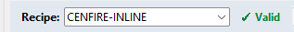

Touchdowns
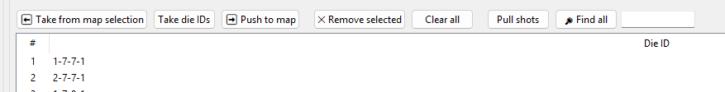
The Touchdown List says which dies this recipe actually probes, and in what order — leave it empty and a run walks every die on the wafer map instead. To edit this touchdown list, you will need a wafer builder map already setup, preferably with die ids labeled. You should then go to run tab, then select dies and save them here, or select dies from recipe tab directly. Either way it will be synced between the two tabs (if not it, it is bugged).
⬅ Take from map selection builds the list from whatever dies are currently picked on the Run tab’s wafer map; Picked dies will be colored orange as selected.
Take die IDs builds a list by actually reading through the wafer map and automatically selected dies that have an id on them. (this is a way to make it easier for you as the user. You can label die ids that you want to test, and then press this button so that it will only select dies you wanted to test).
➡ Push to map does the reverse, selecting this list’s dies back on the Run tab’s map so you can see them.
✕ Remove selected and Clear all edit the list directly;
Pull shots is an experimental button, but low risk. It will select the first die of every shot that you defined in wafer builder tab, this makes it easiest for you to build a touchdown list of all shots so that you don’t have to manually click each one.
Find all is similar. It searches for a die ID (or partial match) and adds every matching die at once. (for example, for lamp, I was able to just type in PCM and grab all 21 positions without needing to manually find them).
The status line above the list tells you at a glance whether any touchdowns are set at all (“No touchdowns — the run walks every die on the wafer map” if not), how many there are, and how many carry a die ID.
Remember that recipe tab DOES NOT edit the wafer map. It only selects dies (highlights them on run tab) and builds a list of dies to move to for that specific recipe. Different recipes can have different touchdowns. Remember to press SAVE after all these steps to finalize the recipe.
You can also change the order of the touchdown list to tell the software for how to move the wafer around for the entire run. This is how you can tell the software to move left to right, bottom to top, or whatever order.
Tips for making recipes: remember to put delays whenever needed, but not too much (50 ms for short, 200 ms for long, is about how much I have deduced experimentally, however you can even do 0 ms for just a buffer). Use open steps whenever needed to mitigate risk, but remember to open all at the end of the recipe. Look at the lamp or maddy or cenfire or peanut ata folders for examples of how recipes are setup, it will give a good idea of where to start. You can even copy recipes from internal tab, different projects if you want to start from a base template (won’t copy wafer map with it though).
Touchdown lists should be constantly checked to be synced. The touchdown list uses rows and columns, but the die ids doesn’t necessarily have to be defined, so bugs with die ids can definitely appear with poor organization.

Run
This is the tab you’ll live in once a project is actually set up – it's where you pick a recipe and probe card, drive the chuck by hand, and start an actual run. In fact, for normal operation during the production line, this is the first tab to load into.
At the top: a Recipe dropdown and a Probe Card dropdown and Wafer Map dropdown, then a row of buttons – (with a green border, since it’s the one that matters most) ▶ Run, followed by ⏏ Unload (U), ⏸ Pause, and ⏹ Stop Run. A state label on the far right (IDLE / RUNNING / etc.) shows what’s currently happening.
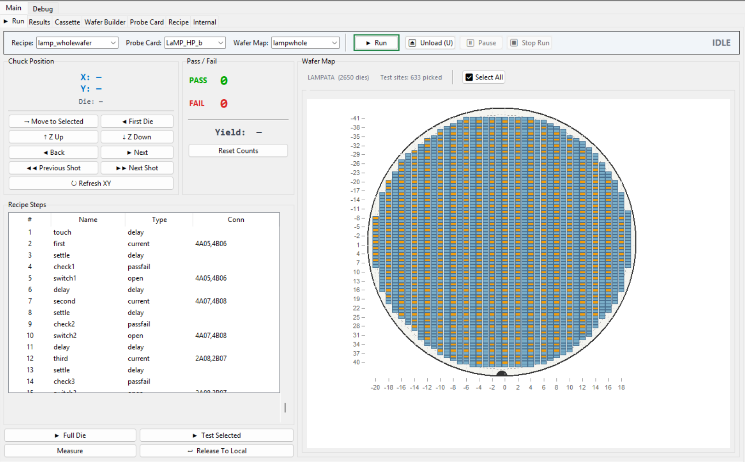
On the bottom, there are some buttons that shouldn’t be used for normal operation, but do exist.
▶ Full Die probes every die the current recipe marks as a touchdown, start to finish, on the currently loaded wafer, regardless of what you set in overlay tab. ▶ Test Selected does the same but only for whichever dies you’ve picked on the Wafer Map to the right (click dies to select them, or use ☑ Select All). Test selected does not call upon any saved map nor does it save a map, just use it for debugging mostly.
▶ Run is the real, full-story entry point: unlike the other two, it also plays back the recipe’s own saved touchdown list and (Accretech) Minor Moves – this is what you want for an actual production run, not just a quick test.
Released to Local button is useful for debugging the instruments. When using GPIB communication, the equipment such as DMM will be rendered into a REMOTE mode, which will not allow any physical buttons to work. The front panel will not respond, the gpib bus will make it busy. If you want to disconnect the software from the equipment, you can press this button to momentarily disconnect. However, if you press refresh or any run afterwards, it will reconnect the equipment.
Now, the Measure button is a bit different and is useful for debugging. It does not do any xy moves, it just does touchdown if zdown and takes one reading at the current position. This reading is whatever recipe is loaded currently. It will go through all the steps. However, if minor moves is enabled, it will stop prematurely if any move step is included.

Wafer Map / Die Selection
The Wafer Map panel on the right shows the currently loaded wafer, colored by die. Click a die to pick/unpick it for ▶ Test Selected – ☑ Select All picks every die at once. If all dies are selected, the button will show Deselect All, which will clear the selections. (hint: double click the button to quickly clear). A small status line above the map (“Test sites: N picked”) tracks how many are currently selected, next to a label naming where the map data itself came from (“Accretech” for the prober’s own internal map, or “Wafer Builder” on Electroglas, which has no internal map of its own – see the Electroglas section of this manual). Scroll to zoom, and middle-click drag to pan; double-clicking resets the view. The wafer map can go off the screen if you pan too far, so just reset if that happens. Main thing to check when wafer map is loaded is to zoom in and make sure die ids are loaded and overlayed correctly.
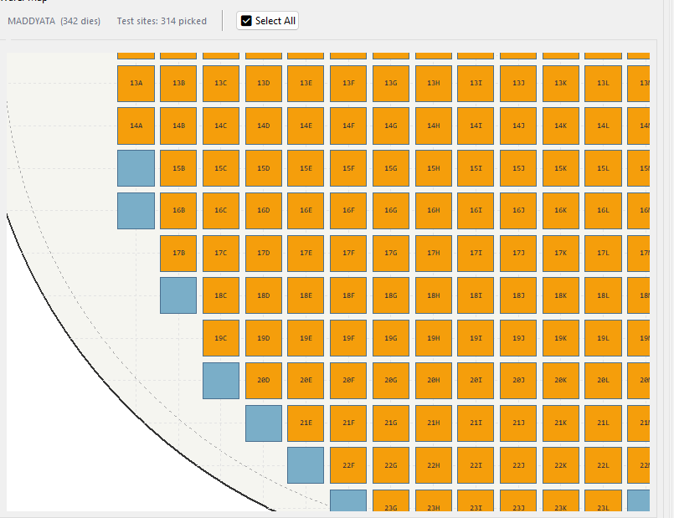

Manual Move Controls
The Chuck Position box (top left) is your manual control of the chuck outside of an actual run – useful for checking a probe card is landing where you expect before committing to a full run. ⏮ First Die sends the chuck back to the wafer’s first die. ⬆ Z Up / ⬇ Z Down raise and lower the chuck (contact vs. safe separation – see the Prober Debug tab later in this manual for exactly what those commands do at the GPIB level). Remember that the status of Z condition of the chuck is on the prober, the software is not able to query this status, but there is little risk for clicking more than once because prober has failsafes built in.
⏮ Back / ⏭ Next step the chuck one die at a time (only Next is an actual GPIB command, Back, previous shot, next shot are pseudo commands coded by calculating from the map) ; ⏮⏮ Previous Shot / ⏭⏭ Next Shot do the same but by shot (a shot can cover more than one die – see Wafer Builder later in this manual for how shots are built). Remember that the shot is defined by you, not the prober. If the button does not do anything, most likely is that it reached the end of the wafer, or no die behind current.
➡ Move to Selected is an arm/target control: click it once to arm it, then click a die on the wafer map, and the chuck walks there. This served to be very useful for me, it gives full control to move anywhere you like.
↻ Refresh XY re-reads the chuck’s current X/Y from the prober by hand – the X/Y readout above these buttons normally updates on its own during a run, this is for checking it manually the rest of the time.
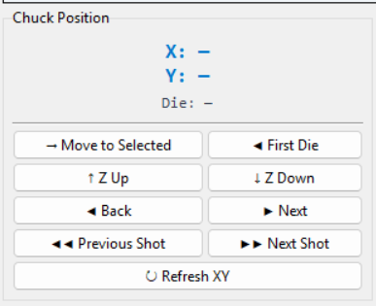
The X and Y rows should match exactly what the prober says, refresh xy if not synced. Die will show the die id, or just the row column if none set.

Start / Stop / Abort
⏏ Unload (U) sends the unload command by hand, outside of a run – useful if you need the cassette to hand back the current wafer without going through a full automated cassette sequence (see the Cassette tab later in this manual). ⏸ Pause finishes whatever step is currently in progress, then holds where it is – pressing ▶ Run again resumes from there. ⏹ Stop Run is a real stop, not a pause – it does not try to leave the wafer in a resumable state. It will reset to the beginning if you press Run again.
Pass/Fail (top right, next to Chuck Position) tracks the current run’s counts live – a PASS number, a FAIL number, and a computed Yield percentage. Reset Counts zeroes all three; it does not undo or re-run anything already measured, it just clears the tally so the next run starts counting from zero.
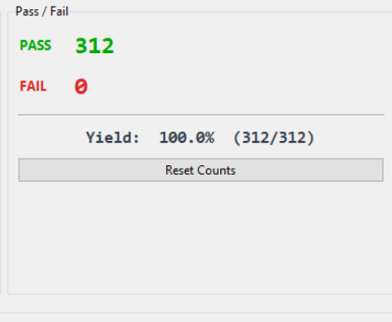
Verify the recipe that has been loaded through the table on the bottom. You cannot edit anything from here though.
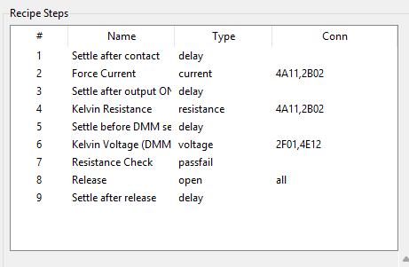

Something important to do at every startup is to verify that the correct dies are selected for each recipe.

Results
Three stacked sections, drag the dividers between them to give more room to whichever one you need: a pass/fail wafer map at the top, Data Export controls in the middle, and the raw Measurement Results table at the bottom.
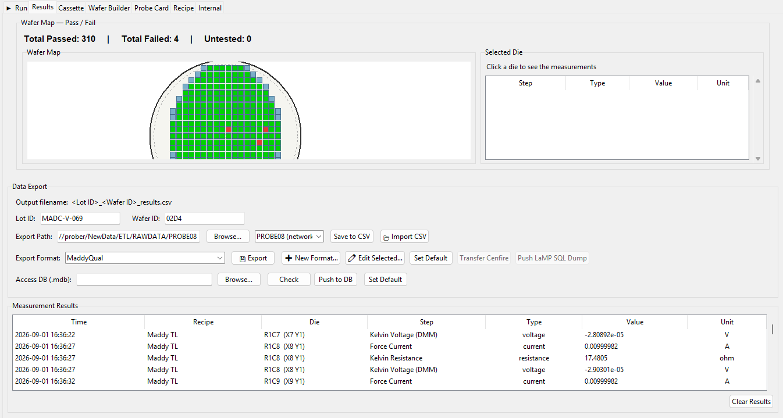

Results Table
Measurement Results, at the bottom, is the raw log of every reading taken so far this session — one row per measurement, with Time, Recipe, Die, Step, Type, Value, and Unit columns. This is the same data Save to CSV and the Export Format system draw from; it isn’t itself filtered by Lot ID/Wafer ID, it’s just everything measured. Clear Results empties this table (and the in-memory results it’s backed by) — there’s no confirmation prompt, so don’t press it before you’ve exported anything you still need. You should clear results after saving data, if you want to start another run. The software is able to just take only one data point per die id, but it can be buggy if table still holds old data. (Cassette automation can handle this also).

Selected Die Table
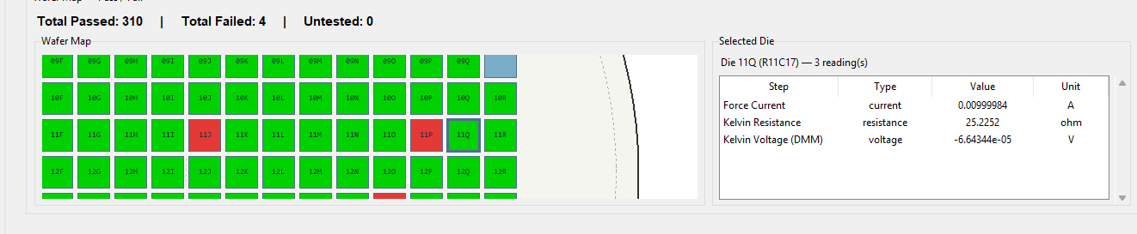
This is useful to see measurement data per die. The table also shows die id, but this top functionality allows you to zoom in out of the map (this map is actually fully live to the run tab, it will update in real time during the run even). Click on any die to see the data assigned to that die id. It will show the recipe steps that are assigned to it, measured or not. (See recipe section, this is dependent on what die number you assign to the recipe steps). If you clear results, just click on another die and back to just resync it. You cannot edit the map or start or stop run from this tab.

Pass/Fail Summary
The Wafer Map — Pass / Fail box at the top colors every die by outcome and gives you a running total (“Total Passed: N | Total Failed: N | Untested: N”) above the map. Click any die to see its own readings in the Selected Die box to the right — before you’ve clicked anything it just says “Click a die to see the measurements”; afterward it lists every step/type/value/unit recorded for that specific die.

Export Formats
There are two things you should save for each run, the results csv and the export file. The export file is whatever the export format defines for that project, you can choose from multiple from dropdown or use the format editor to create a new export format. The results csv file is a useful backup for the data, that can mainly be used to import back into the software later (see Importing Data section below).
An Export Format is a saved column layout for a specific downstream target — this is what actually turns raw measurement rows into whatever a legacy database or upload tool expects. Pick one from the Export Format dropdown, then press Export. New Format… opens the format editor to build one from scratch; Edit Selected… opens the same editor pre-filled with whichever format is currently picked. Set Default marks the currently-picked format as the one this ATA folder should preselect next time.
Now to go over the format editor:
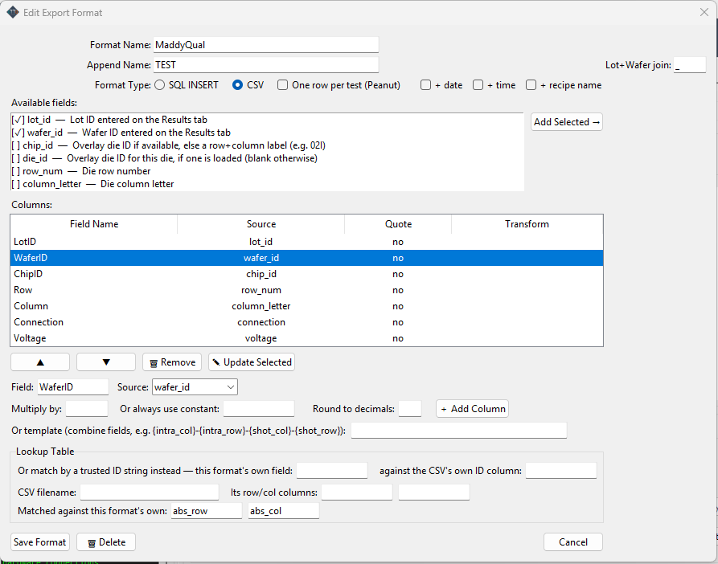
I recommend you to play around with the formats as needed, or change code if you need more. As long as you save the results csv backup file, the data won’t be lost, and you can try importing and exporting again as you develop a format.
Format Name will not show on the final file, just in the software to select the format. Append Name will show on the final file at the end. The file format can be sql or csv (sql was for lamp only, so it may be hardcoded, so you might need to fix code for other projects). One row per test was for direct wiring that didn't have switchbox, so it may be buggy for other projects. You can then append date, time (hour minute second), as well as the recipe name that ran that specific run to the file name itself. Lot + wafer join allows you to put something between the lot id and wafer id (only used for cenfire currently).
In available fields table, you can add what you want to be in the actual file cells. Selecting will add it to the column table. (if more fields are needed in the future, you will need to go into code). In the columns table, you can arrange the order, remove, and edit.
Quote (checkbox per column) — wraps that column's value in quotes in the output file. Useful for a text field a downstream tool might otherwise choke on (a die ID with a dash in it, for instance) — leave it off for anything numeric. Multiply by / Or always use constant / Round to decimals — three independent ways to transform a column's raw value before it's written: Multiply by scales the reading (e.g. flip a sign, convert units). Or always use constant ignores whatever the source field actually reads and just writes the same fixed value every time — useful for a column a downstream table expects but this project has no real data for. Round to decimals rounds the (possibly already-multiplied) value to N decimal places. You can combine Multiply and Round together; a constant or a template column doesn't take either, since they already produce an exact string you chose. Or template — instead of one field, combine several into a single text column using {field_name} placeholders (e.g. {intra_col}-{intra_row}-{shot_col}-{shot_row}). Whatever's in the curly braces has to be a real field name from Available Fields. Columns table controls — ▲/▼ reorder the selected column (this is the order they'll actually appear in the output file, left to right), Remove deletes it. Click a row to load it back into the fields above for editing, then Update Selected to save your changes into that same row — I just fixed this: it used to delete the row the moment you clicked or double-clicked it, before you'd touched anything, which looked like a bug (and was a real footgun). It matches the Recipe tab's own Add/Update Selected/Remove pattern now. Lookup Table — the advanced section at the bottom, for pulling in a value from an external reference CSV rather than from this run's own results (Cenfire's is the main real user of this today). Two ways to match a row in that file against a die: By a trusted ID string — match this format's own field (e.g. a die ID you already trust) against the lookup CSV's own ID column directly. Preferred whenever you have a real per-die ID, since a position match can silently be wrong if the two files don't agree on which corner is (0,0) or which axis is which — there's no way for the software to catch that kind of mismatch, it would just look like "no match" or, worse, a wrong match. By row/col position — match this format's row/col fields (default abs_row/abs_col) against the lookup CSV's own row/col column names, when there's no trusted ID to join on instead. Only fill in one or the other, not both.
Once again, this editor can be buggy, future versions should refine it.

Database
A few buttons below that are shortcuts to external/legacy paths rather than the format system above: Transfer Cenfire launches the same external AzTransfer tool LabVIEW used to invoke after a run (only enabled when a Cenfire ATA folder is loaded); Push LaMP SQL Dump does the equivalent push for LaMP, but does the database write itself rather than handing off to another program (only enabled for a LaMP ATA folder).
The Access DB (.mdb) row further down is a separate, more general path: point it at any .mdb/.accdb file, press Check to confirm the target table and columns actually match the picked Export Format (a SQL-style format, not a plain CSV one), then Push to DB to insert the last run’s rows directly into that file — with a confirmation prompt first, since a push to a shared network copy is immediately visible to everyone reading it and cannot be undone. Set Default (next to it) remembers this .mdb path for the current ATA folder.
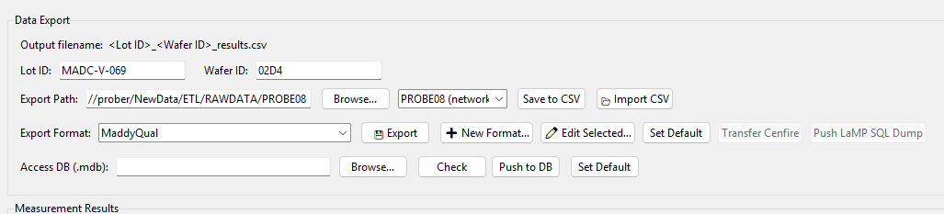

Export Path / Lot ID
The Data Export section names the CSV it will write right up top: <Lot ID>_<Wafer ID>_results.csv — so filling in Lot ID and Wafer ID first is what actually names the file. Export Path is where that file (and the Export Format below) goes; Browse... opens a folder picker, and on Accretech there’s also a quick-pick dropdown next to it (PROBE08 network share, Cenfire-DataDump, C:\data, or your Downloads folder) so you don’t have to browse to the same few places every time.

Importing Data
This is one of the most useful functionalities in my opinion. This allows you to view data long after the run. If you want to see the wafer map, the pass fails, the data per die, etc, you can use this button. You will need to find the results csv that was previously mentioned. When you press import csv, it will open the file explorer, select the correct results csv, then it will auto load everything. In fact, you don’t even need to be in the correct ata folder, it will figure out what ata folder, recipe, and map that data belongs to and will load everything for it. I recommend using this outside of the fab also, you can just open the software on any local computer and import csv and view the data to analyze it, or export in another format, or view the pass fail yield if the format didn’t save it.
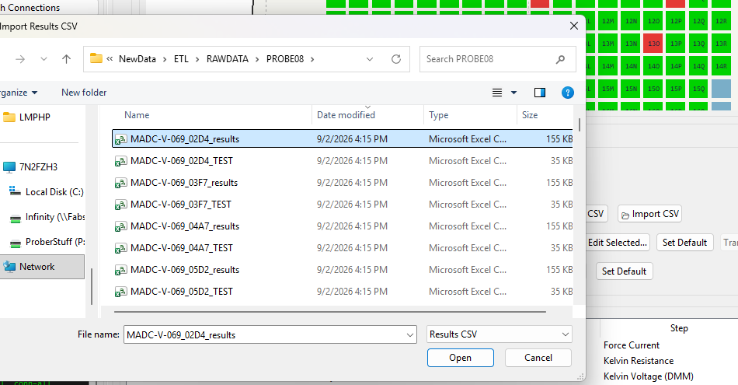
To reiterate, Save to CSV button writes the plain, self-contained results CSV right now, using whatever Lot ID/Wafer ID/Export Path are currently filled in. The results csv holds other information in the first row of the csv to help with auto loading. Import CSV does the reverse — pull a previously-saved results CSV back in, e.g. to re-export it in a different Export Format later.

Cassette
If you have more than one wafer in a cassette, then you should use this tab. This tab drives a whole cassette load end-to-end instead of one wafer at a time: you load the physical cassette, build a list of what’s in each slot (Lot ID + Wafer ID), start the first wafer normally from the Run tab, then arm this tab — from there it watches for that run to finish, auto-exports it, checks yield against a threshold, and if it’s fine sends the unload/load-next command and starts the next slot’s run automatically, repeating until the list is done or the cassette reports no next wafer.
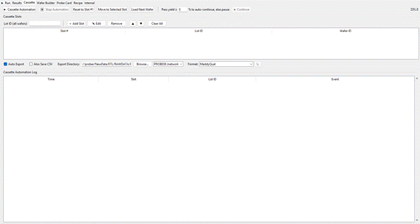
This is cassette tab, here you can define the lot and each wafer in the slots such that the whole lot can be automated and the data can be exported automatically.
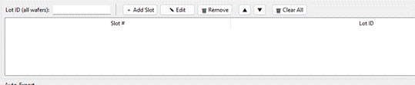
Fill in the lot id (e.g. LMPD-1921). Then for the wafer ids, click add slot, a window will popup.
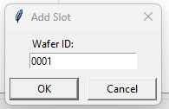
Fill them in one at a time, making sure that first slot is the bottom row of the cassette, because the prober loads wafers sequentially from bottom to top. (meaning the wafer closest to H bar is wafer 1).
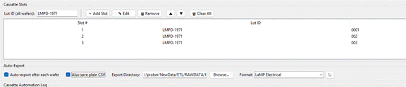
Once you have it filled out, make sure auto export is checked. It is also recommended to have save plain csv, which makes it so you can import and view data afterwards.
Check that the export directory is where you want it, the export directories will be synced with results tab.
On the top right bar, you will see a pass yield percentage. It is there so that if a wafer has too many failing dies, the automation will pause and you will need to press the continue button after confirming everything looks ok, or if you want to skip, etc. You can change or reduce the percentage to 0, if you don’t want this feature enabled.
Once done, press Cassette Automation button. You should see it say “ARMED- waiting…” Now you still need to start the run for the first wafer, but it will take over afterwards and run the rest of the wafers in the same way as the first.
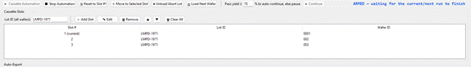
If you need to reset, click reset to slot 1. If you happen to skip a wafer manually on the prober (because of alignment error and you pressed load next wafer), then you can move to selected slot so that the code knows which slot it is on also. You can also check the prober to see how many wafers left to run. If you need to manually load next wafer or just unload the entire lot to abort, those buttons are included as well.

Slot List (Add / Edit / Remove)
Fill in a Lot ID (shared by every wafer in the cassette) at the top of the Cassette Slots box, then use Add Slot to add one row per physical wafer, in the order they sit in the cassette — slot #1 is whatever you already manually loaded and started on the Run tab. Edit changes the Lot/Wafer ID of the selected row; Remove deletes it; the ▲/▼ buttons reorder the selected row; Clear All empties the whole list (asks for confirmation first if it isn’t already empty).
Auto Export and Also Save CSV, plus the Export Directory row right below the slot list, control what happens automatically each time a wafer in this list finishes — they reuse the same export path/format machinery as the Results tab (see that section of this manual), just triggered per-wafer instead of by hand.

Arm / Disarm Automation
▶ Cassette Automation arms the automation once the slot list has at least one entry and nothing else is already watching for the run to finish — from then on this panel takes over after whichever run is currently going (or the next one you start). ⏹ Stop Automation disarms it at any point without touching the wafer currently loaded. Reset to Slot #1 rewinds the tracked position back to the start of the list (blocked while armed) so you can rerun the whole cassette from the beginning.
Move to Selected Slot is bookkeeping only — the prober’s cassette mechanism has no “jump to slot N” command, only sequential unload+load-next — so this just repoints which slot the automation considers current, for a slot you skipped after an error or want to re-run: click it once to arm, click a slot row, click again to confirm. Load Next Wafer sends the unload/load-next command by hand, outside of automation.
Pass yield ≥ / % to auto-continue, else pause is the threshold this automation checks after every wafer: at or above it, the cassette advances on its own; below it, automation pauses with the wafer still loaded rather than silently burning through the rest of the cassette on a bad run, and ▶ Continue (next to the threshold) resumes from there once you’ve looked at it. The threshold is saved per ATA folder, so a different project can have a different real-world expectation.

Lot Complete Summary
Once every slot in the list has been processed, a Cassette Lot Complete popup appears on its own, listing every wafer’s yield for the lot (Wafer ID: pass/tested (pct%)) and where this lot’s exports were written. Because automation only sends the unload command when advancing to a next wafer, and there is no “next” after the last slot, the very last wafer is left sitting loaded on the chuck — this popup’s ⏏ Unload Last Wafer button is the one-press way to clear it, so you don’t have to go find the equivalent control elsewhere. Close just dismisses the popup; the wafer stays loaded if you don’t press Unload first. Once unloaded, the machine buzzer does go off, so thats why I didn’t automate that last step.

Debug
Under debug section, there are a few tabs that do affect normal operation and a few that just do GPIB debugging, and a few that are experimental tabs or for future development.

Instruments
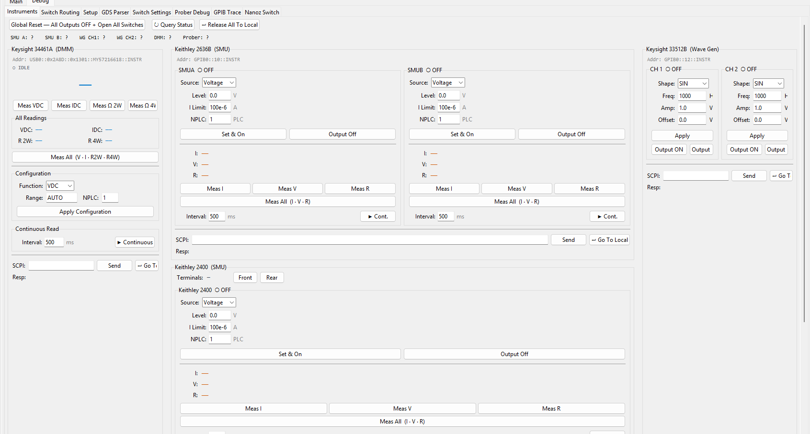
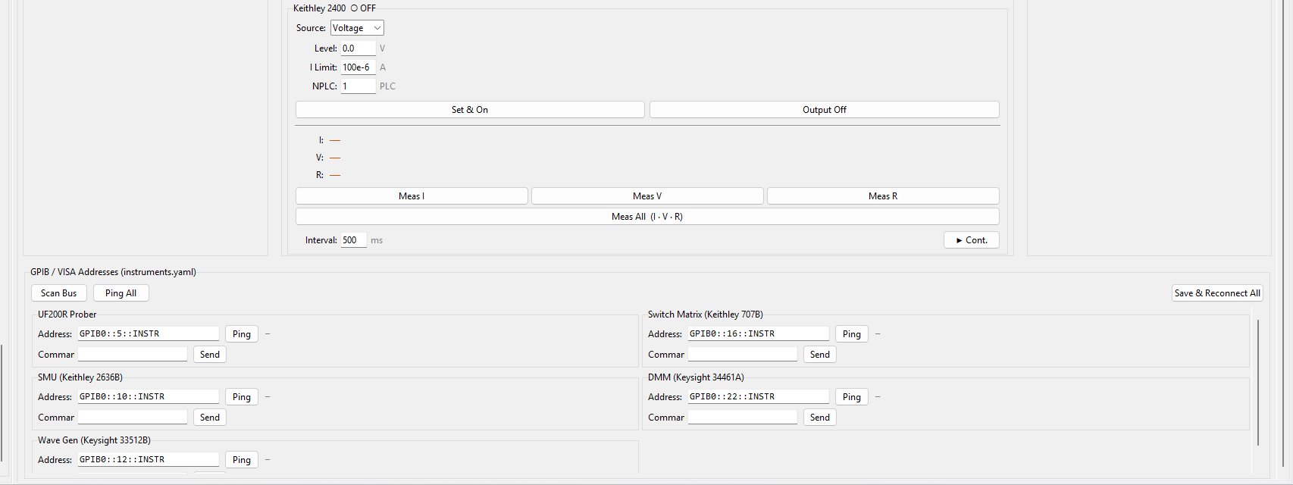
This tab helps with troubleshooting the equipment. Manual, hands-on control of every instrument on the bench — for checking a piece of equipment actually works, taking one-off readings, or driving something outside of a recipe entirely. A bar across the top applies to everything at once: Global Reset — All Outputs OFF + Open All Switches is the panic-button version (kills every output and opens every switch-matrix relay in one press); Query Status re-reads every instrument’s live state; Release All To Local hands GPIB control back to each instrument’s own front panel, releasing the remote status. You will not be able to press any of the buttons on the equipment if its in a remote state. A row of short status labels below that (SMU A / SMU B / WG CH1 / WG CH2 / DMM / Prober) shows each one’s connection state at a glance.
For all the equipment I have also included an SCPI terminal, where you can just send a raw command to that GPIB address. Refer to instrument manuals to see the command set.

SMU
Two cards: a Keithley 2636B (two independent channels, SMU A / SMU B) and a Keithley 2400 (one channel, sharing the same underlying “smu” driver slot as the 2636B — only one is ever really connected on a given bench at a time). Each channel works the same way: pick Source (Voltage or Current), set Level and the opposite quantity’s limit (I Limit when sourcing voltage, V Limit when sourcing current), and NPLC (integration time, in power-line cycles). Set & On applies those settings and turns the output on; Output Off turns it off again.
Meas I / Meas V / Meas R take one reading each; Meas All (I · V · R) takes all three at once. ▶ Cont. starts repeated auto-measurement at whatever Interval (ms) is set next to it — press it again to stop. The 2400 card also has a Terminals switch (Front/Rear) — Rear for a probe card wired through the switch matrix, Front for a hand-clipped direct-wired setup.

DMM
The Keysight 34461A card: four one-shot measurement buttons — Meas VDC, Meas IDC, Meas Ω 2W, Meas Ω 4W (ohmf)— each showing its result in the large reading display above them. All Readings below takes all four at once and keeps every result visible side by side, rather than overwriting the single big display with whichever was measured last.
You can press continuous read to just read at a set interval.

Wave Generator
Two independent channels, CH 1 and CH 2, each with Shape (SIN/SQU/RAMP/PULS/NOIS/DC), Freq (Hz), Amp (Vpp), and Offset (V). Apply sends the current settings to that channel without changing whether its output is on or off; the ON / OFF buttons below it toggle the output itself, and the channel’s own title bar (“CH 1 ● ON” / “CH 1 ○ OFF”) reflects which state it’s actually in.

Connection / Address Setup
The GPIB / VISA Addresses box lists every instrument this bench knows about, two to a row, each with its own Address field, a Ping button (a GPIB serial poll, so it also detects instruments that answer no ID query) and status readout, plus a Command field and Send button for firing a raw query straight at that one instrument. Scan Bus, Ping All, and Save & Reconnect All sit across the top of this box: Scan Bus identifies everything actually answering on the bus (including gear that isn’t even in the configured list); Ping All pings every configured instrument one at a time; Save & Reconnect All writes whatever addresses are currently typed in back to instruments.yaml and reconnects.

Switch Routing
A live picture of the switch matrix, one row of dots per switch-matrix row letter and one column per probe pin (1–24) — green means that relay is currently closed, grey means open. Click a dot to toggle that specific pin/row connection by hand. Open All opens every relay at once (the safe, everything-disconnected state). ↻ Read State re-reads the whole matrix from the instrument and redraws the dots to match reality, in case something closed a relay outside this panel (a recipe step, for instance). The SCPI/TSP box lets you send a raw command straight to the switch instrument and see its response, with Up/Down cycling through your last few commands, same as a terminal history.
Which rows actually appear here, and what each one is labeled, comes from Switch Settings (see that section later in this manual) for the currently active bench — different benches can have a different number of live rows (a bench with no wave generator fitted, for instance, just won’t show a WGEN row).
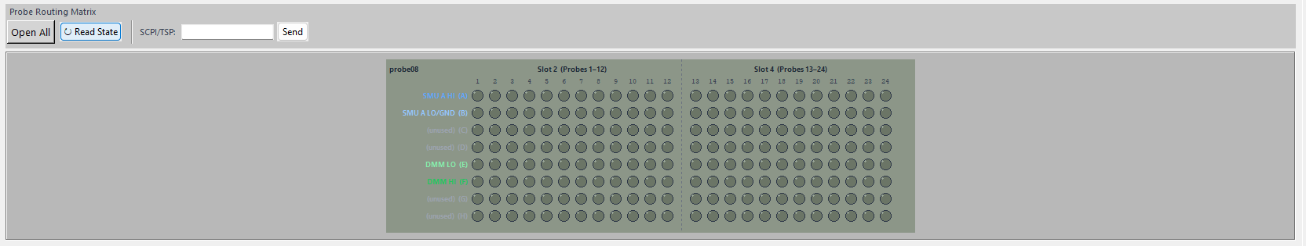
The show routing toggle at the top right of the GUI actually just opens this tab on the bottom of the screen, no matter where you are. It helps during troubleshooting, since you can manually close connections as you please, and you don’t have to keep coming back to this tab to use the functionality.

Setup
This tab edits which prober benches exist and what instruments (model, GPIB address, timeout, fitted or not) each one has, without hand-editing the YAML files those settings actually live in. Editing here only takes effect on next launch, or after Refresh Connections on the Instruments tab — an already-open session keeps whatever it originally connected with.
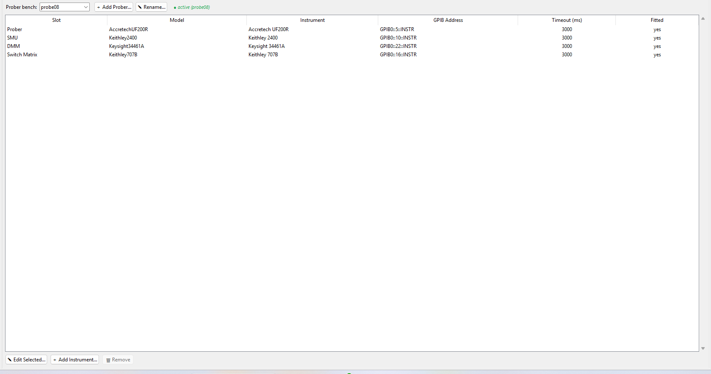
Adding new instruments not included has not been tested, and will probably require code troubleshooting. I have tried my best to allow for drivers to be easily added to the instruments folder in the source code, however, porting those drivers into the actual functions for the run tab can introduce many complexities. For now, the only real verifiable things you can do in this setup tab is to reintroduce past equipment that was already setup, such as putting the Keith 2636b back into Accretech or Wave Generator.

Add / Rename Prober Bench
The Prober bench: dropdown at the top picks which bench you’re editing — the label next to it (green, italic) names whichever bench is actually active right now, since editing a bench you’re not currently on just saves for next time it’s selected. ＋ Add Prober… creates a new bench (prompts for a name, then copies its starting instrument list from whichever bench is currently selected — the fastest way to set up a new probe station that’s wired almost the same as an existing one). ✎ Rename… renames the selected bench.
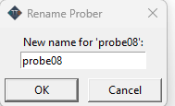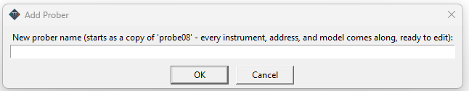

Add / Edit / Remove Instrument Slot
The table lists every instrument slot on the selected bench — Slot, Model, Instrument (display name), GPIB Address, Timeout (ms), and Fitted (yes/no). ✎ Edit Selected… opens a dialog to change the model, name, address, timeout, and fitted state of the selected slot. ＋ Add Instrument… adds a brand-new slot — even for a model with no driver written yet (pick Generic), it will still open the address and answer *IDN? so you at least get a live/dead check. 🗑 Remove deletes a slot (disabled for the handful of mandatory slots every bench must keep).
Uncheck Fitted for a slot that exists in the table but isn’t physically connected on this particular bench — it’s skipped by Ping All (on the Instruments tab) instead of showing up as a false failure, while its own individual Ping button still works if you do plug it in later.
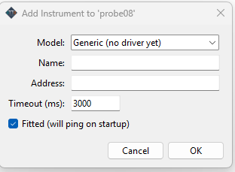
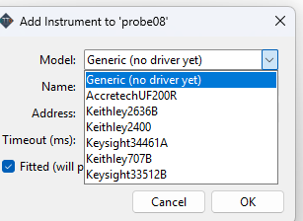

GDS Parser
This is an experimental tab that does not affect any other tab at all yet. It is proposed to help with standardizing GDS files and making it easier to parse those files, extract info and help with alignment on certain wafer maps.

Open / Parse GDS File
Open GDS File loads a .gds layout file; Load Metadata JSON optionally loads a companion metadata file alongside it (its status is shown at the bottom of this control box). Once a file is open, the Cell dropdown picks which top cell in the GDS hierarchy to treat as the wafer layout, and Parse / Refresh re-parses the current file (needed again after changing the Cell, or any of the pad/wafer settings below it, since none of those re-parse automatically).
Pad layer / Pad datatype / Min pad µm / Max pad µm control which shapes in the GDS actually count as a probe pad versus other layout geometry to ignore, plus a Flatten for pad extraction checkbox for a hierarchical layout where pads are nested inside sub-cells. Wafer ⌀ mm / Edge excl. mm / Pitch X µm / Pitch Y µm describe the physical wafer this die pattern sits on, and Use GDS refs as die locations switches between reading die positions from the GDS’s own reference/array placement versus computing a grid from the pitch values. Update Wafer Map re-renders the preview from the current settings without a full re-parse.

Export ATA Files (New vs Merge)
Generate ATA Files turns the currently parsed layout into an actual ATA folder. A confirmation dialog then offers two ways to do that: New ATA Folder… creates a brand-new folder from scratch (prompts for a name), while Merge Into Existing ATA Folder… writes the generated files into an ATA folder that already exists — for regenerating just the wafer-map/probe-card side of a project without disturbing recipes or results already saved there. Cancel backs out without writing anything.

Export Log
Export App Log writes out this session’s Main App Log (the same log every other tab writes to) to a file — useful for keeping a record of exactly what a GDS parse/export run actually did (settings used, warnings, any errors), separate from the ATA files it produced.

Metadata Import
Load Metadata JSON (in the top control row) pulls in a companion JSON file alongside the GDS layout — the Layout metadata status line at the bottom of the control box confirms what was actually loaded, or explains why nothing was. This is optional; a GDS file with no metadata file still parses and exports fine, it just won’t carry whatever extra project-specific information the metadata file would otherwise supply.

Switch Settings
This tab, on the other hand, is very important. It describes how the physical switch matrix itself is wired — which card slots exist and how many pins/columns each covers, how many row letters the matrix has, and which instrument (and channel/polarity) each row connects to. This is the source of truth Probe Card wiring and Recipe steps resolve their HI/LO switch connections from — changing something here takes effect immediately for any step computed afterward.
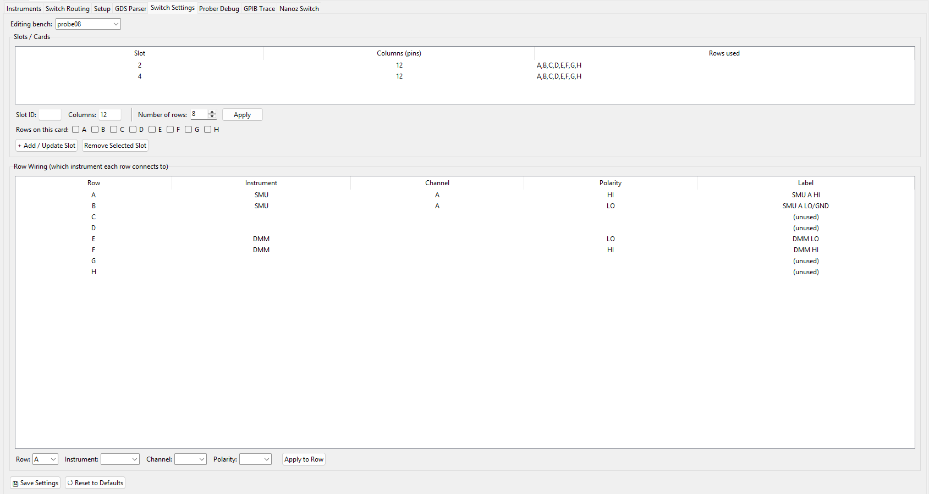
For example, you can see how probe08old was wired, it used to have the 2636b and wave gen, and all rows were being used. Currently probe08 only uses four rows.
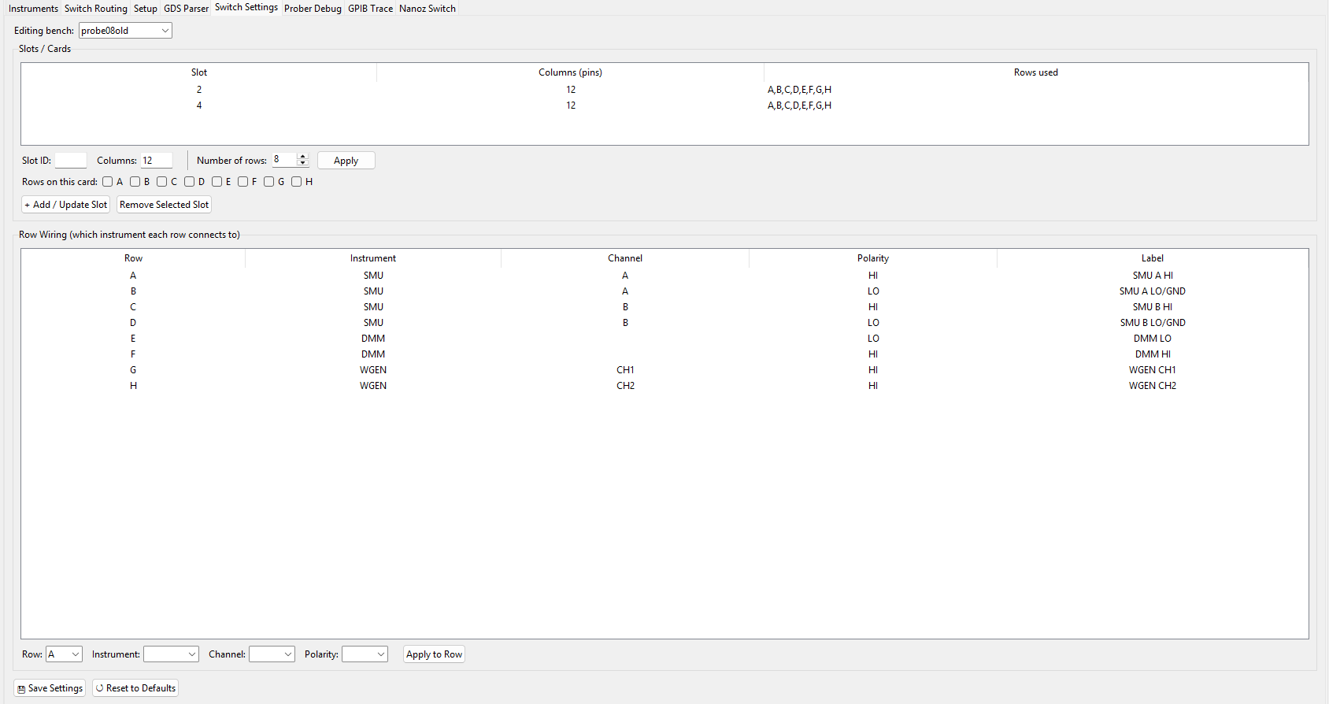

Slot Configuration
The Slots / Cards table lists every physical card slot in the matrix, how many pin columns it covers, and which row letters actually run through it. Select a row to load it into the fields below for editing. Slot ID / Columns fields plus Number of rows / Apply set up a new slot (Apply resizes how many row-letter checkboxes are available to assign, matrix-wide, from topo.MIN_ROW_COUNT up to MAX_ROW_COUNT). Check the row letters this slot should carry under Rows on this card, then + Add / Update Slot saves it — same button whether it’s a new slot ID or you’re updating an existing one. Remove Selected Slot deletes whichever slot is selected in the table.

Row Wiring / Roles
The Row Wiring table shows what every row letter actually connects to — Instrument, Channel, Polarity, and a computed Label, one row per letter. Select a row to load it into the editor below: pick Row, then Instrument (SMU/DMM/WGEN, or blank for unused), Channel (options narrow to whatever that instrument family actually offers, and disable entirely for DMM since it has no channel to pick), and Polarity (fixed to HI and disabled for WGEN, since a waveform generator output isn’t a HI/LO sense pair the way an SMU or DMM channel is). Apply to Row saves it.

Prober Debug
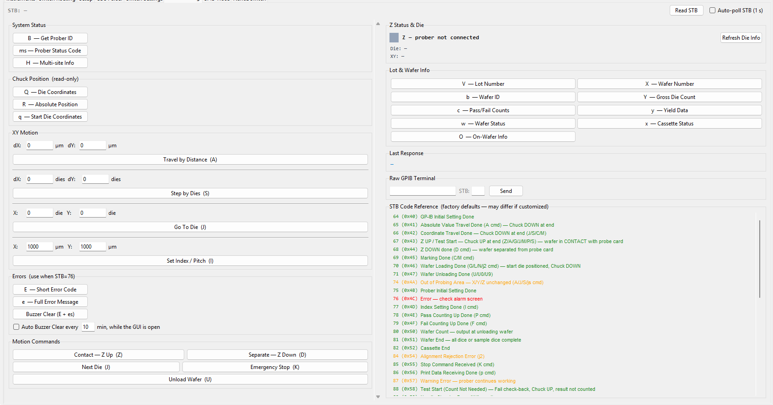
This is a place to troubleshoot and reference the Accretech UF200R itself. In general, there aren’t many commands you can really use. You are welcome to experiment with the ones available, however many are not accepted by this specific prober even though it is in the manual. Nevertheless, the commands and the STB code reference (which is the error codes) can help you diagnose it.

Motion Commands (A/S/J/I/Z/D)
The XY Motion box sends the Accretech’s raw motion commands directly, outside of any recipe — useful for confirming the chuck actually goes where you expect before trusting a run to it. A travels BY a distance from the current position (µm steps, X+ leftward/Y+ backward); S steps by whole DIE INDEXES instead of microns; J moves to an ABSOLUTE die-map coordinate. All three restore chuck height afterward if it was up, and only work in the “Probing” state. I sets the die pitch/index size — only accepted while waiting for lot process start, and wafer/probe-pad alignment has to be redone afterward if you use it.
The Motion Commands box below that has the two chuck-height commands and the ones that step through the wafer: Contact — Z Up (Z) raises the chuck to probing height plus overdrive (the wafer touches the probe card); Separate — Z Down (D) drops it back to the safe, separated position. Next Die (J) advances to the next die; Emergency Stop (K) sends an immediate stop; Unload Wafer (U) unloads. Every button on this tab sends immediately with no confirmation prompt — this is the Accretech Prober Debug tab specifically; Electroglas’s equivalent still confirms before a motion command (see that section later in this manual).

Raw Command Console
The Raw GPIB Terminal at the bottom right sends any command string straight to the prober — type it in and press Send (or Enter). An optional expected-STB field next to it lets you note down what status byte you expect back, for your own reference while testing. Last Response, just above it, shows the most recent command/response pair from anywhere on this tab, not just this terminal.

STB / Status Polling
The STB readout at the very top of the tab shows the prober’s current status byte. Read STB reads it once by hand; Auto-poll STB (1 s) next to it keeps reading automatically once a second, so the readout tracks the prober live while you work through other buttons on this tab. STB Code Reference, at the bottom of the right-hand column, is a scrollable lookup table of every known status byte value and what it means (colored red for an error code, orange for a warning, green for everything else) — these are the factory-default meanings and may differ if this prober’s firmware has been customized.
System Status, top left, groups the read-only identity/status queries: B — Get Prober ID, ms — Prober Status Code, and H — Multi-site Info. Errors (use when STB=76) has E — Short Error Code and e — Full Error Message for reading back what actually went wrong, plus a combined Buzzer Clear (E + es) that reads the error and clears/silences the alarm in one press — Auto Buzzer Clear every ⟨N⟩ min next to it repeats that automatically for as long as the GUI stays open.

GPIB Trace
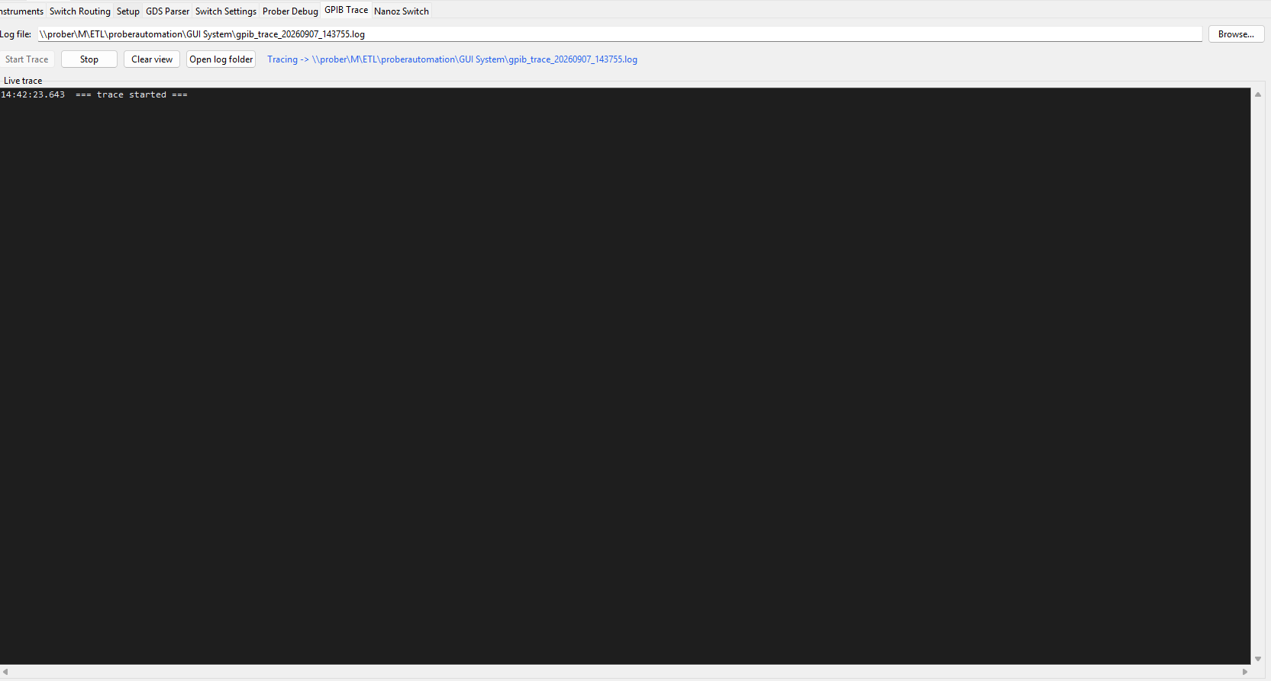
A live log of every write/query/read/serial-poll this app itself sends over GPIB or USB (switch matrix, SMU, DMM, prober), each with a millisecond timestamp — useful for diagnosing exactly what got sent and when, without guessing from higher-level log messages. It can only see this process’s own traffic; to compare against LabVIEW’s own commands, run NI I/O Trace alongside it (Start Menu → “NI I/O Trace”, or NI MAX’s Tools menu) — that hooks the driver itself, so it sees any app’s traffic with no setup needed here.
Log file names where the trace is written (Browse… to change it); Start Trace begins recording, Stop ends it, Clear view empties the on-screen log (the file on disk is untouched), and Open log folder opens the folder containing it in Explorer.

Nanoz Switch
This is for the Nautilus project only. Refer to that manual for more details.
Switches the whole window into NanoZ mode — a separate main workspace built for the Nautilus 1x20-shot boards, replacing this window’s Main/Debug section entirely (see the NanoZ part of this manual). Debug tabs like this one stay reachable either way; switching back is available both from here and from NanoZ mode’s own header.
Switch to NanoZ / Switch to Normal change the window’s current mode right now. Startup default’s Set NanoZ as Default / Set Normal as Default instead set which mode the app opens into the next time it’s launched, independent of whichever mode you’re actually in at the moment you press one.
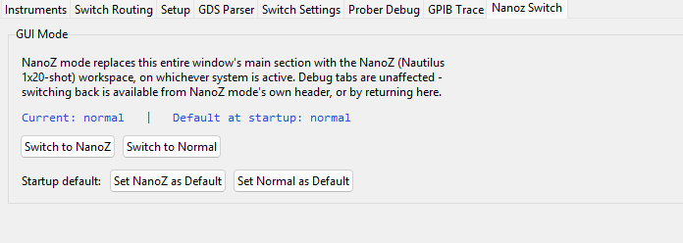

Electroglas
The Electroglas 2001CXE has no onboard wafer map or die-ID memory of its own the way the Accretech does — it moves relative to a die you set by hand (Set Initial, on the Run tab) and steps from there, with Wafer Builder supplying the actual die layout/IDs and xy positions rather than anything read off the prober. Its motion commands are pre-SCPI and answer no *IDN?, so presence is confirmed by GPIB serial poll instead (see Prober Debug later in this manual). The tab set below mostly mirrors Accretech's — Run, Results, Recipe, Probe Card, Wafer Builder, Internal, Debug — with an added PMA Process tab for loading legacy .PMA/Recipe Generator files, and no Cassette tab. Main things to remember is that this is an older device, it will inevitably hang, be slower, may not receive commands immediately, and overall needs more caution. Please refer to the Operation and Tips manual for an guide on using this tool.

Main
Same shape as Accretech’s own Main section (see that part of this manual for the toolbar/top-bar controls, which are shared code) — the toggle on the top bar switches which system is active, and the tabs below it are Electroglas’s own versions of Run, Results, Recipe, Probe Card, PMA Process, Wafer Builder, and Internal.
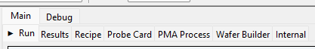

Internal
Same tab, same code, as Accretech’s Internal tab (see that section of this manual for the full detail on Load ATA Folder/New ATA Folder, Working Directory, Default prober, Cassette pass-yield default, and the ATA Folder Browser tree). The only real difference: the Key ATA Files list filters to whichever files actually belong to Electroglas (plus whatever’s shared between both systems) — a file that’s Accretech-only won’t show up as “missing” here.
Remember that to have Electroglas on startup, select an electroglas specific prober system on the default prober dropdown.

Wafer Builder
Same tab and sub-tabs (Shot, Shot Map, Die Map) as Accretech’s — see the Accretech Wafer Builder section of this manual for the full detail. The difference is that there is no Accr Wafer or Overlay tab — Electroglas has no internal wafer map of its own to line this map up against, so Wafer Builder’s map simply IS the wafer as far as the Run tab is concerned. Take care to define your maps correctly.
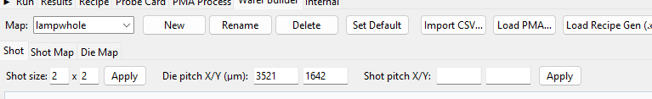
IMPORTANT: Define the die pitch accurately here. Unlike Accretech, the die pitch DOES affect operation. For MM mode, it uses it to do the actual moves. For MD mode, it will send the pitch to the prober in the form of a GPIB command.

Shot
Identical to Accretech’s Shot tab (see that section of this manual) — shot size/die pitch/shot pitch, click to add/set order, right-click to remove, shift-click to name a slot.

Shot Map
Identical to Accretech’s Shot Map tab (see that section of this manual) — wafer size, click to toggle a touchdown, ☑ Fill All / ☐ Clear All.

Die Map
Identical to Accretech’s Die Map tab (see that section of this manual) — Set Die ID / Mark Skip / Mark Align click modes, Save Wafer Map, Export CSV.
The difference here is that once you Save Wafer Map, it will load into run tab. (on Accretech, you need to overlay first).

Import / Export
Same Import CSV… / Load PMA… / Load Recipe Gen (.xls)… buttons in the toolbar, and Export CSV on the Die Map tab, as Accretech’s (see Import / Export under the Accretech section of this manual). On Electroglas, Load PMA… here only fills in this tab’s own Shot/Shot Map/Die Map — it does not extract info the way the PMA Process tab’s own LOAD ALL does (see that section of this manual), so use PMA Process for actually setting up a run from a legacy file, and this tab’s Load PMA… only when you specifically want to reshape Wafer Builder’s own map from one.

Run
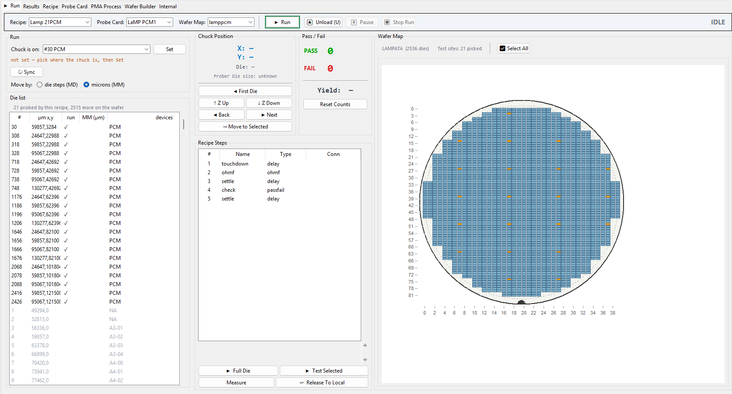

Wafer Map / Die Selection
The Wafer Map on the right works the same way as Accretech’s (click to pick dies, ☑ Select All, scroll to zoom). Please make sure to select the correct wafer map from the dropdown, zoom in and check die ids to make sure.
The Die list on the left (its own box, next to Set Initial and Run) is a second, table view of the same wafer — every position, not just the recipe’s touchdowns. It also shows the currently-here / already-done positions highlighted directly in the table, as well as dies to be probed by that specific recipe. Selecting a row there is another way to pick a die, alongside clicking the map itself.
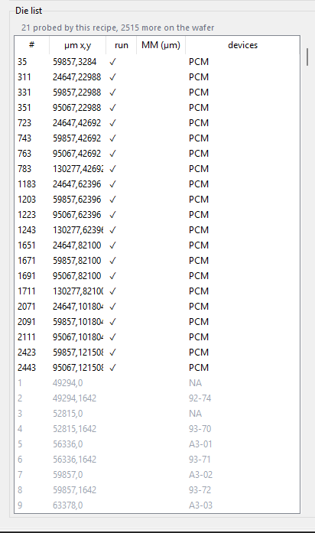

Set Initial Chuck Position
This is where a run actually starts from: Chuck is on: is an editable/filterable dropdown — type to filter a whole-wafer die list down to what you’re looking for, or just type a die ID directly — then Set tells the software that’s where the chuck physically is right now. Everything else on this tab is relative to that anchor, so this has to be right before anything else here means much; the status line below it says whether an anchor is currently set.
You will not be able to move until this is done. On recipe tab, you can set an align die to be default. No matter the method, you will need to align the die on the prober itself (as shown on full operation manual), then look through the microscope to verify what die it is on (for multi die shots, check the die that is labeled as die number 1 in wafer map, eg. for lamp it is top left of the quad). Once you have the die id, go to the dropdown and pick out that die id, and press set.
This will basically sync the wafer map on the software and the coordinate system of the prober itself. (Note, you can pick any die on the map, you don’t even need to press First on the prober). Once synced, you should see a border around the current die position on the wafer map itself as well as the xy position numbers show up.
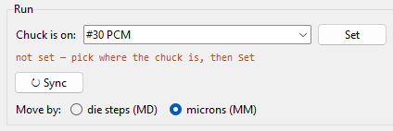
Sync will query the prober for the position again, and then fix what die it is currently on (essentially a refresh xy button from accretech).

Move Mode
Move MM (µm) uses and shows the MM Pitch values that the wafer builder tab has set for it. Mode die MD uses the probers built in parameters to move dies using a reference (FIRST die). As a result, the correct parameter does need to be loaded into the prober. See prober operation manual, but the xy pitch is stated on the screen. The GUI can also attempt to infer that parameter (because there is no command to query the prober), and it will show what it gets on the grey text under chuck position section.
For lamp, MM is default. I recommend testing other projects with both modes, MM is preferred, but does have the risk of not moving perfectly with the pitch, since it is referencing micrometer distances. It also relies heavily on whether you set the die pitch correctly on wafer builder map. Also verify that the correct wafer map is selected on dropdown.
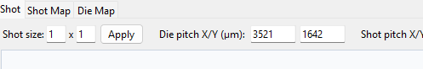

Start / Stop / Abort
Uses the same ▶ Full Die / ▶ Test Selected / ▶ Run / ⏏ Unload / ⏸ Pause / ⏹ Stop Run buttons at the top of the tab as Accretech’s Run tab (see that section of this manual) — ▶ Run on Electroglas specifically drives this pane’s own full recipe playback rather than the generic Accretech run path. The moveset for that specific run will be shown on the die list table AFTER the chuck is set. For example, it will tell you that next move is MD+1+0, or +10-12, or MM +1000+1000, etc. This should help with troubleshooting. Pass/Fail counts and Reset Counts work identically on both systems.

Results
Identical layout and controls to Accretech’s Results tab — see that section of this manual for the full detail on every field.
Data saved using export formats don’t know which system it came from, but the import results csv does know the system. If you import csv it will autoload into the correct prober.

Recipe
Same tab as Accretech’s — Recipe/Probe Card pickers, Touchdown List, Measurement Steps table (see the Accretech Recipe section of this manual for the full detail, almost all of which is genuinely shared code). The differences are narrow and called out below: Electroglas doesn’t get the Compute Connection / ↻ Compute All buttons (its per-bench relay wiring isn’t reliable enough across projects to compute a trustworthy switch connection automatically — see the Probe Card section for why), and its shot origin comes from a manual capture button here rather than Wafer Builder’s Overlay tab. Your options for instruments are also limited, right now Keithley 2400 is the only one on switchbox, with the other DMM maybe used for PCM tests.
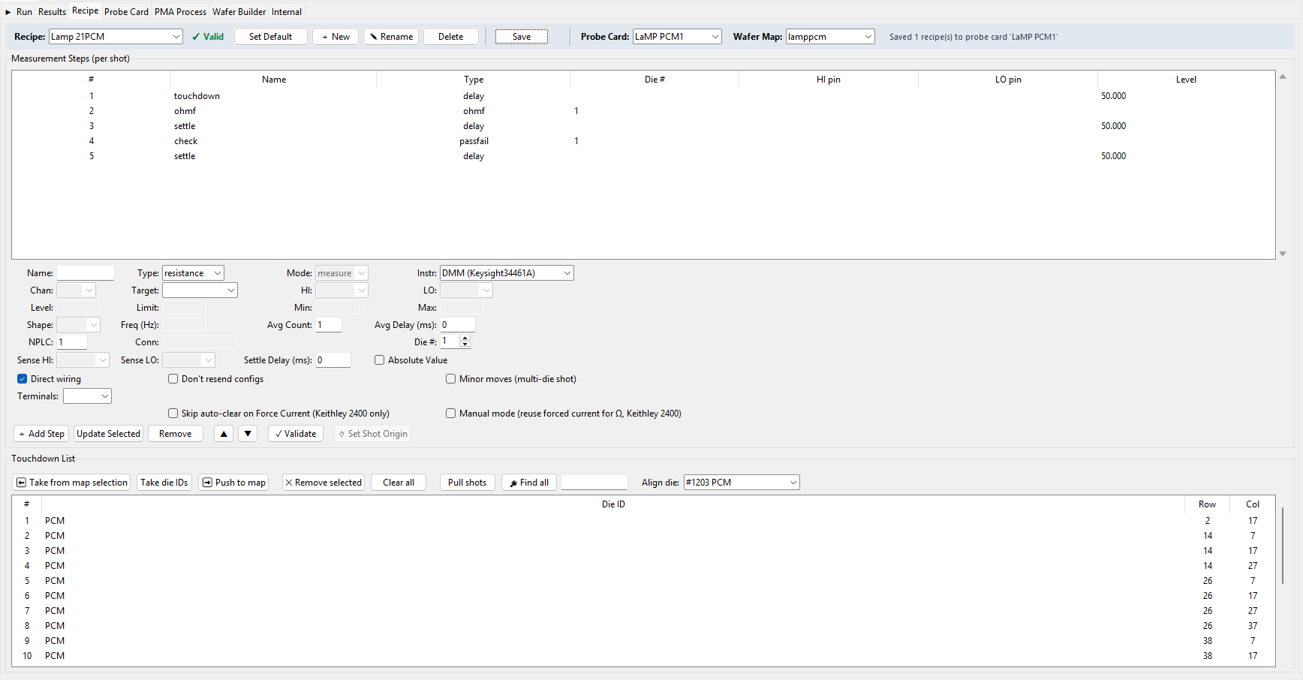

Touchdown List
Once again, check your touchdown list, verify the order is also good, so the wafer doesn’t jump randomly across the map.

Validate Recipe
Same ✓ Validate button, however, can be buggy, so check or ignore the recommendation if anything seems off.

Probe Card
Same tab as Accretech’s Probe Card tab (see that section of this manual for the full detail). Remember that the pins for Electroglas is different however, its not the 24 pin setup. As a result, if you happen to need to wire up a new probe card, you will likely need to figure out what connector to use, what relay to work with, how its going to connect. It is not as simple as Accretech. You can look at the settings tabs in the debug section to get an idea of how the switchbox for Electroglas works, however, it will require manual wiring and planning to setup.
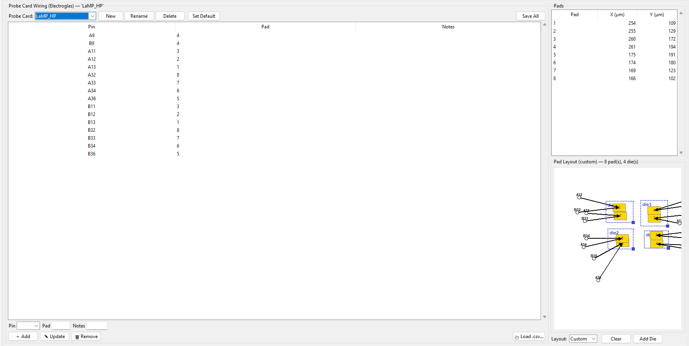
In most cases other than lamp, I would not try to fill out Probe Card tab accurately, just use it as an organization label. If the system changes or if the switchbox setup is more streamlined in the future, please fix the code accordingly and allow for more customization. If the relays are updated, you can update settings first, then experiment with probe card tab afterwards.
For lamp, as shown in the picture above, the connector is double sided, with A and B sides. I believe A is the only one that is actually wired to the relays, nevertheless I did provide the pinouts for lamp_hp card. Lamp pcm card is direct wiring, so obviously left it blank, but you can fill it out if one day, things change with the wiring. As of now, the only recipe using the probe card pin-switch is lamp.

PMA Process
Electroglas-only. This is where a legacy .PMA (and optionally its companion Recipe Generator .xls) can be loaded to get turned into a wafer builder map and extract info about the recipe. However, I would verify all imports first and make sure it loads correctly, because pma files can vary greatly, and the parser is not guaranteed to get all info accurately. I would only recommend to use to help you fill out the wafer map die ids.
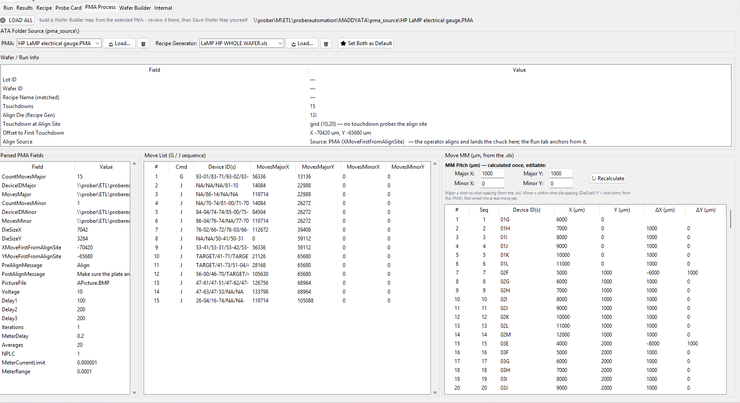

Load PMA / Recipe Generator File
Recipe: and Recipe Generator: each have their own dropdown (populated from files already brought in) plus a Load… button to browse for a new one and a 🗑 button to remove the selected entry from the list. Set Both as Default marks the currently-picked PMA and Recipe Generator as the pair to auto-load for this ATA folder next time.
⚙ LOAD ALL, at the top of the tab, will attempt to build a wafer map for you. Then, you will have to check the tab and save it.

Debug

Instruments
Electroglas’s equivalent of the Accretech Instruments tab, laid out per-bench rather than per-card: a Prober bench box at the top shows which bench is active (chosen from the Prober box in the toolbar, not here) and how many instruments it has fitted, with ↻ Scan bus & match to identify the bench from what actually answers on the GPIB bus right now, in case the wrong one is selected. Below that: an SMU — Keithley 2400 card (Source Voltage/Current, Level, Limit, Output ON/Output OFF/Measure — same shape as Accretech’s 2400 card, see that section of this manual), then DMM and Power Supply cards (below), then the GPIB/VISA address list at the bottom.
[SCREENSHOT NEEDED: Electroglas Instruments tab, full window – Prober bench box, SMU/DMM/Power Supply cards, address list at the bottom.]

DMM — HP 3458A
A full debug panel for the HP 3458A multimeter, not just a couple of measure buttons. Meter picks the measurement function (DCV/ACV/OHM 2W/OHM 4W/DCI/ACI/FREQ, etc.); ↻ TERM? which terminals reads back which input terminals are in use (a mechanical switch on the instrument itself — read-only from here). ACAL runs the meter’s own internal calibration routines (disconnect the input first). Range/Autorange ON/OFF control the measurement range. Configuration has on/off toggles plus NPLC / NDIG / ACBAND fields with their own Set buttons for integration time, display digits, and AC bandwidth. Reading’s ▶ Measure once takes one reading into the display; a Raw field with Send lets you fire any other SCPI command straight at the meter.
[SCREENSHOT NEEDED: HP 3458A debug panel – Meter/Range/Configuration boxes and a live reading.]

Power Supply
The Agilent 6634B card: Voltage and Current Limit fields, Output ON / Output OFF / Measure buttons, and a reading display — same shape as the SMU/DMM cards on this tab, just for a bench power supply instead of a source-measure unit.
[SCREENSHOT NEEDED: Power Supply card with Voltage/Current Limit set and a live reading.]

Connection / Address Setup
Same GPIB / VISA Addresses box as Accretech’s (see that section of this manual) — Scan Bus / Ping All / Save & Reconnect All at the top, one row per instrument below with its own Address/Ping/Command fields. The roster of instruments listed here follows whichever bench is active (see Prober bench, above) rather than a fixed list, since different Electroglas benches genuinely carry different instruments at different addresses.

Setup
Same purpose as Accretech’s Setup tab — edit which benches exist and what instruments each one has — with its own, separately-maintained bench list (Electroglas benches genuinely differ in what’s fitted; see the module note on the Instruments tab). Remember that adding or removing instruments can break the code, just use with caution, and verify that drivers port over accurately.
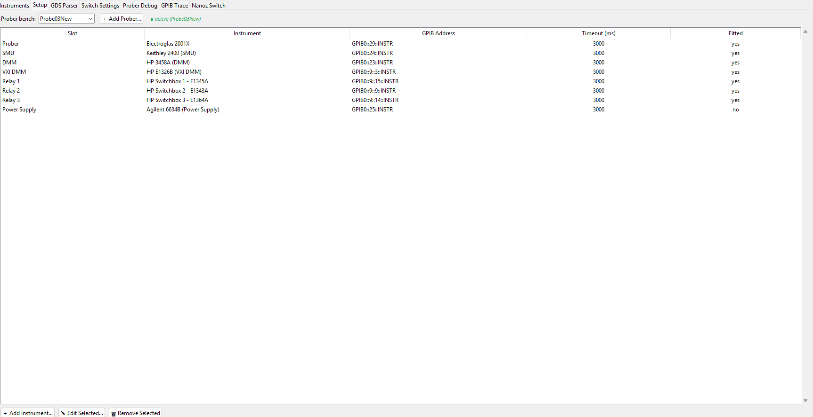

GDS Parser
The exact same tab as Accretech’s — GdsParserPanel is shared, unbranched code with nothing system-specific about it (see the Accretech GDS Parser section of this manual for full detail on every control).

Switch Settings
A different, simpler tab from Accretech’s own Switch Settings — Electroglas gets a switchbox test panel instead: pick a probe card from the dropdown, then double-click any row in the table (card, channel, pins, known assignment) to assign it. Open all opens every relay on the switchbox at once; ↻ Refresh re-reads the current assignments. A status label at the right of the top row shows idle/busy state while a command is in flight.
[SCREENSHOT NEEDED: Electroglas Switch Settings (switchbox test) tab, full window.]

Prober Debug
Electroglas’s equivalent of the Accretech Prober Debug tab — direct, low-level control of the 2001CXE’s own command set. Unlike, Accretech however, this prober gives you much more control over the chuck. In fact, you may want to use the joystick buttons and theta control for alignment. Theta control is especially useful, as there is no actual manual theta control on the physical prober itself. For theta control, set a unit to step by, and then press the clockwise or counterclockwise buttons. I recommend checking the microscope or camera to see whether it works. I also recommend querying the current theta position using MT command, it can help you keep track. Send to 0,0 position is also a useful button to send to first die.
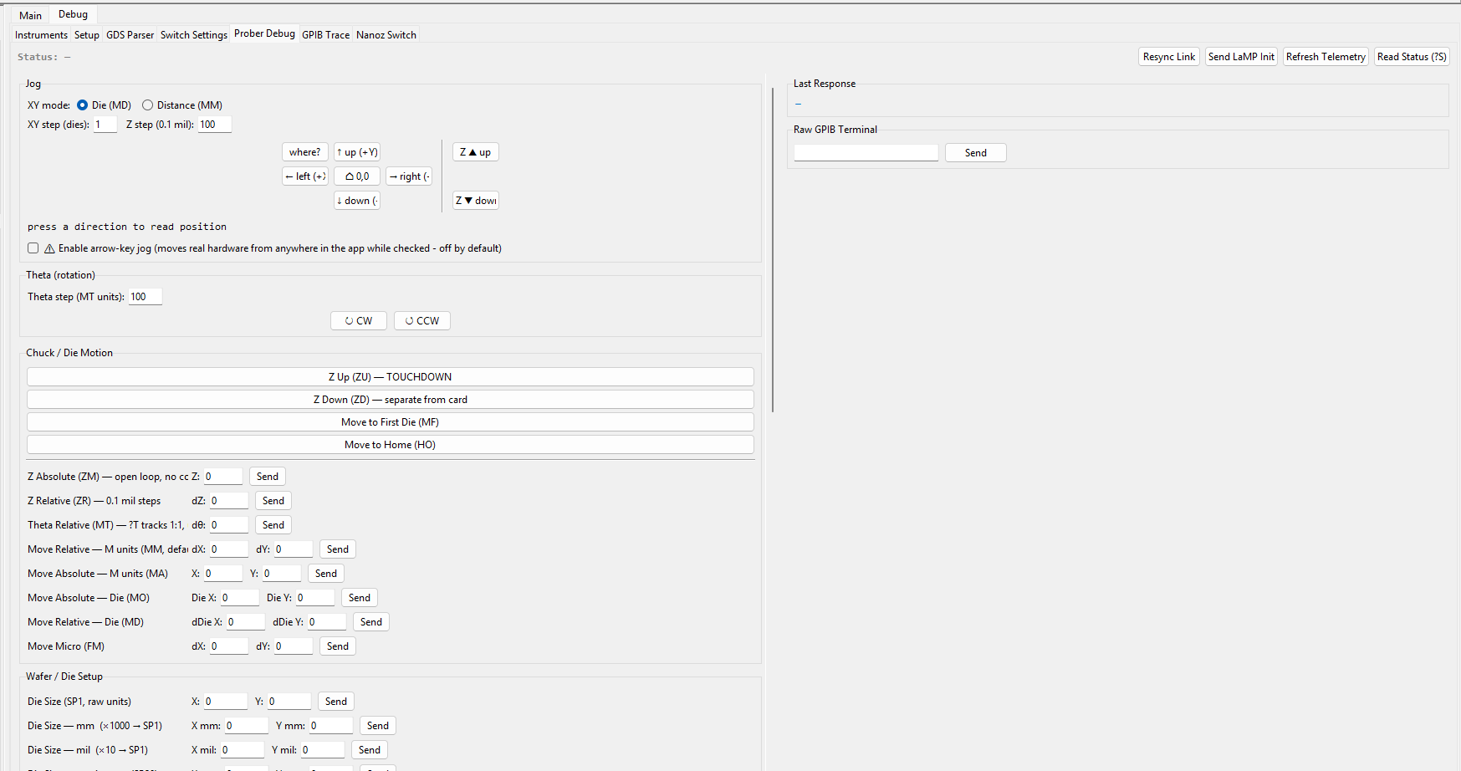
As for the rest, status bar at the top shows the prober’s live status string (this prober reports status as text via ?S, e.g. “idle”, “moving”, “error: ...”, rather than a numeric status byte — see STB/Status Polling under the Accretech section of this manual for the contrast). Read Status (?S) reads it once; Refresh Telemetry reads every other verified query at once and logs the decoded result (read-only, no motion or configuration change). Send LaMP Init is old and is just hardcoded. It replays the 20 configuration commands recovered from LaMP’s own startup sequence — it only ever sends SP/SM/SO/SX/WM setup commands (nothing moves), but it does overwrite this prober’s current Z setup, so it shows exactly what it’s about to change and asks for confirmation first. Resync Link unwedges the GPIB link after a timeout (drains, sends a device clear, reopens the session — none of it moves the machine), which used to require restarting the whole app. I would not use any of these buttons, but you can experiment with them, or maybe replace them for something more useful.
Unlike Accretech’s Prober Debug tab, every motion command here still asks for a yes/no confirmation before sending — this asymmetry is intentional (see the oddities report), since a wrong guess about this prober’s coordinate/motion behavior is harder to recover from than on the Accretech.

Jog Controls (Theta/Z)
The Jog box drives the chuck like a joystick. XY mode picks whether the arrow pad moves by Die (MD, relative die steps — the only XY motion verified to track exactly with ?P) or Distance (MM, relative microns); XY step / Z step set how far each press moves. The 5-button pad (↑/←/⌂ 0,0/→/↓, plus a where? button that just reads back the current position) moves relatively in whichever mode is selected; ⌂ 0,0 walks the chuck to die (0,0) step by step rather than in one jump. Z ▲ up / Z ▼ down jog height by the Z step amount. Arrow-key labels are only confirmed against a bottom-right (load-position) datum — after re-anchoring at a different datum, verify the physical direction by eye before trusting them, and the whole pad only responds to real arrow-key presses at all once you explicitly check Enable arrow-key jog (moves real hardware from anywhere in the app while checked — off by default, and deliberately not left always-on, since an unscoped binding here once sent a live jog command to whichever prober happened to be active, Electroglas or Accretech, from a keypress made on a totally different tab).
One jog moves at a time — presses made while a move is still in flight are dropped rather than queued, since the prober itself already queues unfinished commands and stacking more on top of that would just pile up travel nobody asked for. The Theta (rotation) box below it works the same way: set a step, then CW / CCW — MT’s unit is not confirmed to be degrees, so treat direction/scale as approximate and verify by eye (or against ?T) before relying on it; normal operation leaves rotation to Auto Align (AA) instead of manual jogging.
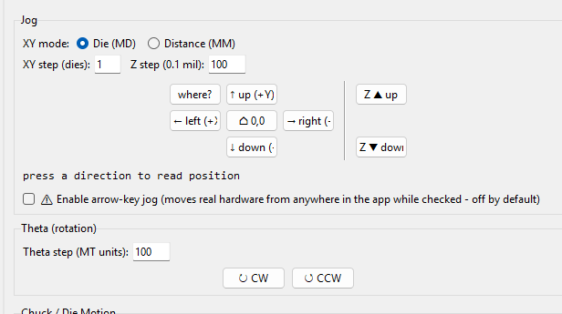
(note that zup and zdown uses edge sensors. To move z by increments you will need to use actual joystick, see full operation manual).

Infer Die Size
Infer Current Die Size, in the left column below the Wafer / Die Setup group, works out the currently-set die size even though the 2001CXE has no direct query for it — useful for confirming what’s actually configured on the prober right now without having to already know it. To infer though, the chuck needs to be currently on a position off the 0,0 axis (eg. 1,2 will work). The software also attempts to infer when chuck is set.

Raw Command Console
The Raw GPIB Terminal, bottom right, sends any command straight to the prober — type it and press Send (or Enter). Commands starting with '?' are sent as queries; everything else is written as-is, and a known motion mnemonic typed here still asks for confirmation first, same as the dedicated motion buttons elsewhere on this tab.
The left column below the jog controls is the rest of this prober’s command set, grouped into labeled boxes: Chuck / Die Motion (Z Up/Z Down, Move to First Die, Move to Home, plus the parameterized Z/Theta/XY move commands, each with its own Send button and confirmation), Wafer / Die Setup, Z Limits & Profile, Counters & Yield, and Wafer Expansion & Time — each just a list of that category’s setup commands with fields for whatever values they take.

GPIB Trace
Same as Accretech

Nanoz Switch
Same as Accretech

NanoZ
NanoZ mode replaces this window’s Main section entirely with a workspace built for the Nautilus multi-shot boards — up to several DAQ boards, each with two chips, run measurement cycles against dies wired into whichever probe-card slot they’re assigned to. It works on whichever system (Accretech or Electroglas) was active when you switched into it — see Nanoz Switch, in the Accretech/Electroglas Debug sections of this manual, for how to get here and back. Board I/O, the shot list, Pass/Fail limits, Charts, Results, and NanoZ_EK are all prober-agnostic; only the Run tab’s manual-move handlers and its wafer-plan/wafer-map data source differ by system, branched inline rather than duplicated into a second implementation.
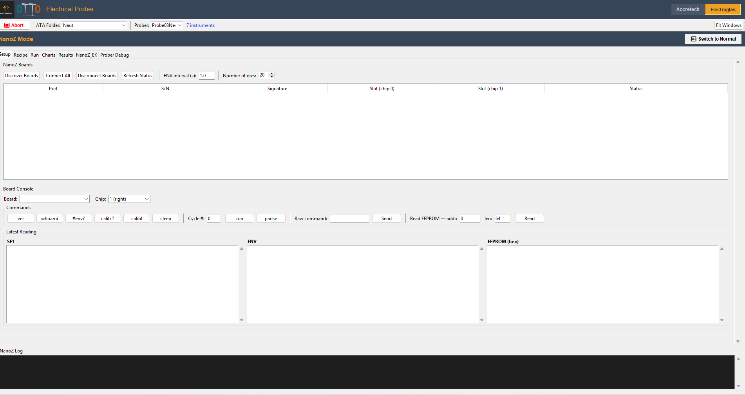
To return just press this button: 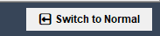
Also, refer to Nanoz Switch tabs under Debug to show how to switch TO Nanoz.

Setup
NanoZ Boards lists every connected board, live. Number of dies sets the probe head’s slot count (a probe-card property, not a fixed constant — some cards are a full 1x20, others 1x2/1x3/single-die); this drives the valid range everywhere else on this tab, on the Run tab’s position window, and on the wafer-plan window height when computing a recipe. ENV interval (s) sets how often environmental sensor readings refresh.

Discover / Connect / Disconnect Boards
Discover Boards scans for boards physically present and adds any new ones to the table. It scans COM ports, since DAQs are connected via USB. Connect All opens a connection to every discovered board at once; Disconnect Boards closes them. Refresh Status re-reads each connected board’s live state. The Board Console below the table lets you talk to one board/chip directly: pick Board and Chip, then use the Commands row (ver, whoami, #env?, calib ?, calib!, cleep, a Cycle #/run/pause pair, a Raw command/Send field, and a Read EEPROM addr/len/Read control) — results land in the SPL / ENV / EEPROM (hex) panes under Latest Reading.
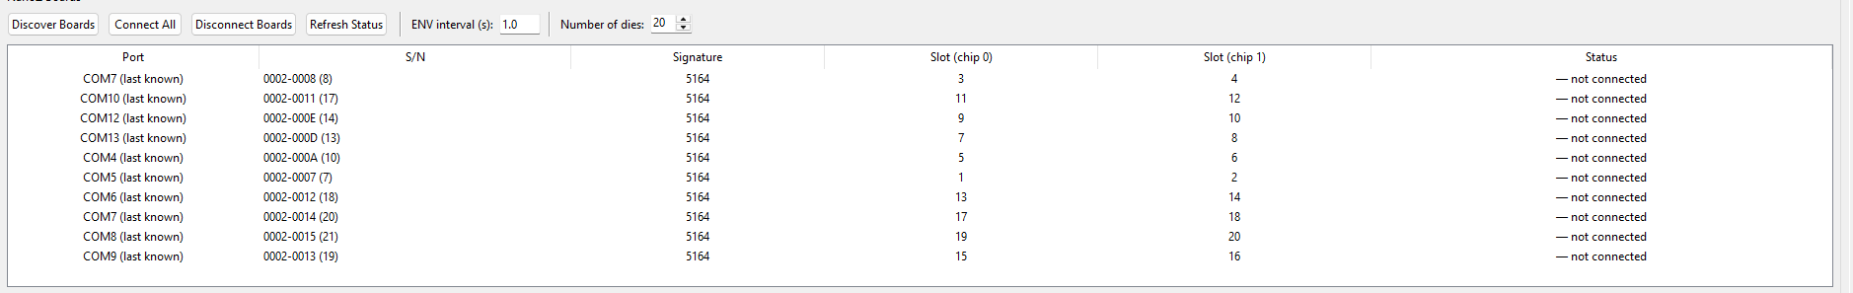

Board Assignment
Double-click a board’s Slot (chip 0) or Slot (chip 1) cell in the NanoZ Boards table to assign that chip a physical probe-card slot (1 through however many dies the probe head has, top to bottom) — this is what actually ties a board/chip to a specific position on the wafer for measurement, and it’s the only way to set it; there’s no separate assignment dialog elsewhere on the tab. Chip 0 refers to slot 1, chip 1 refers to slot 2 (it is unfortunately defined that way for the DAQ boards). First die is the top die of the shot (don’t trust the J connectors on the breakout board for the ordering - J20 is the top die).
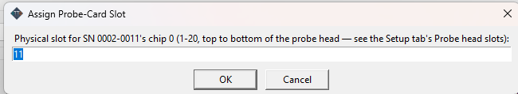

Board Assignment
Underneath is board console - an assortment of buttons and commands coming from the DAQ manual itself. Under that is some tables of latest readings, just raw values only, from all boards. For more board specific data and organization, see the charts and results tab.
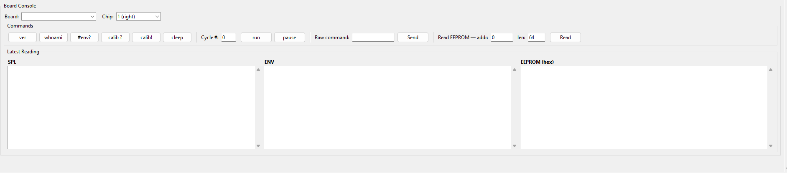

Recipe
Named Recipes, a Touchdown List, and a Measurement Steps table with Pass/Fail Limits underneath — the same overall shape as the normal (non-NanoZ) Recipe tab, but sized for the Nautilus boards rather than SMU/DMM steps.
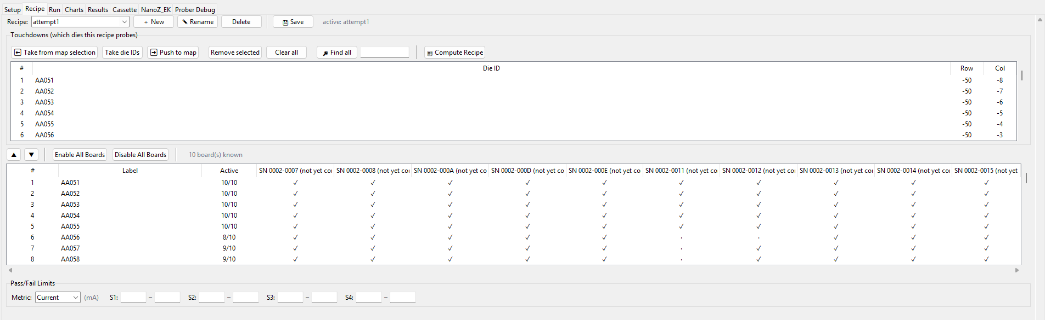
Note: For this system, probe card and wafer map is just taken from whatever normal version has, I didn’t allow for switching inside nanoz side. If wafer map doesn’t load, switch to normal and fix there.

Overview
For Nanoz, the equipment is the DAQ boards, - no switchbox, no GPIB, less flexibility. The DAQ boards are set to be able to just run a cycle when you tell it to and thats it. (Use the dedicated software to figure out how to program the cycle, or check Nanoz_EK tab to read what the cycle is doing). As a result, the recipe tab here does mainly two things: it figures out which dies to touchdown on such that the window covers every die (shots defined by the length of the window- set in Setup tab) and it figures out which DAQ boards to run a cycle on and which ones to leave off for each touchdown.
For example, if you are measuring 20 dies at a time, but you are on the edge of the wafer for a specific touchdown, you don’t want to run a cycle on every single board. The recipe tab allows you to choose which ones (from top to bottom - defined by the slots numbers in setup tab) to run for each touchdown.

Named Recipes (New / Rename / Save / Load / Delete)
The Recipe: dropdown picks which saved recipe you’re editing; ＋ New / Rename / Delete manage recipes by name, and Save writes the current one. The label next to Save shows whether anything is saved yet (“(no recipe saved yet)” until you save your first one).

Shot List
The Touchdown List says which dies this recipe probes — ⬅ Take from map selection builds it from dies picked on the Run tab’s map, Take die IDs does the same by typing/pasting IDs directly, ➡ Push to map selects this list’s dies back on the map, ✕ Remove selected / Clear all edit it directly, and Find all searches for and adds matching die IDs at once. Remember to just select the top die of the window for each touchdown, you don’t have to select every die, or else it will actually move to every die and just repeat dies.
Compute Recipe button is the Nanoz’s way of automatically figuring out which DAQs to turn on per touchdown. If you have touchdown list filled out already, you can press this button and it will fill out the table below it with the an attempt at figuring out how to run cycles on every DAQs at every move such that all dies are covered, but dies aren’t tested twice and pins outside of the wafer map is not tested.
Measurement Steps, below the touchdown list, works like the normal Recipe tab’s step editor — add/update/remove steps, reorder with ▲/▼, and toggle Enable All Boards / Disable All Boards for which boards a given step actually runs on. Pass/Fail Limits, at the bottom, sets per-sensor min/max thresholds (S1 through S4) for whichever metric (Current or Resistance) the recipe measures. Pass fail limits and cycles are just universal, you can’t do different ones for different dies at the moment unfortunately. Checkmark on the board column means it will be run for that touchdown and rows show the touchdowns, etc.
NOTE: The DAQ boards will run both slots of its board if you run a cycle. Unfortunately, the DAQ boards does not have a way of only running one of its two slots at a time. As a result, there are 10 boards, and so you can enable or disable these 10, (which means enabling or disabling two at a time). This also means that there are still possibility of overlapping tests, or testing dies twice, which shouldn’t affect operation or damage dies, but may affect the export format. Please experiment with the export and maybe try to save only the latest reading only or some variation of that. You can save multiple data points per die.
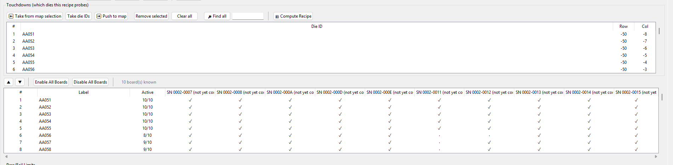

Run
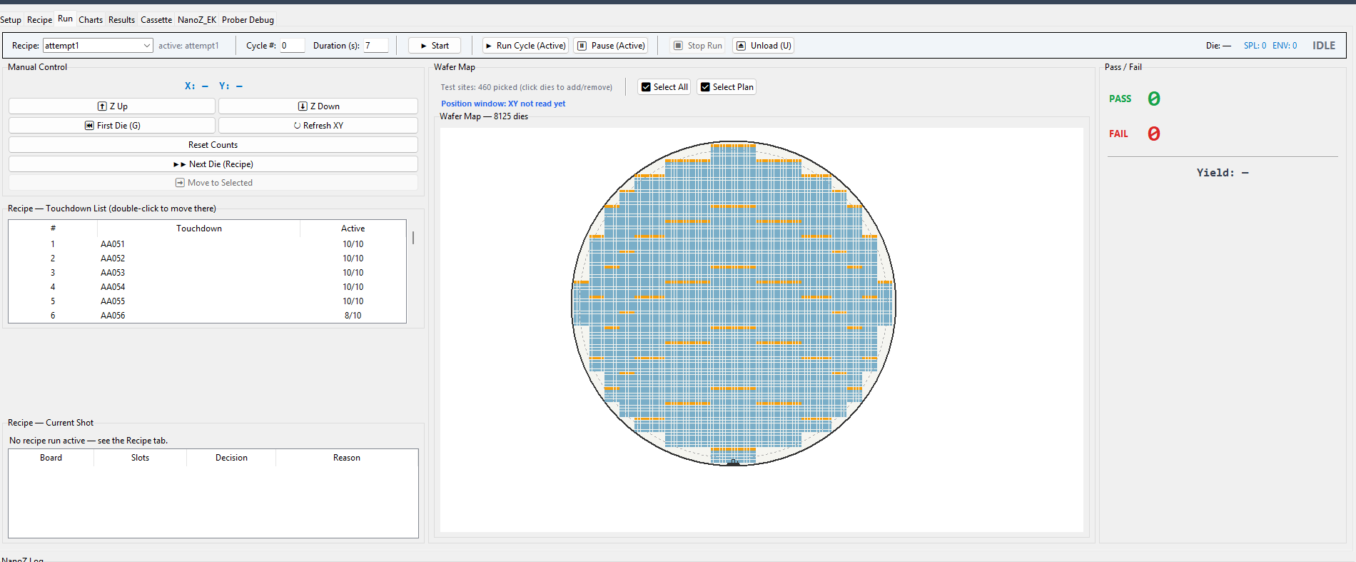
Most are similar to Accretech operation. Main thing is that the recipe is just running a cycle, so you can actually just pick what cycle to run (usually just 0, the first and only one on the boards). You can press run cycle to run a cycle on every board once (no moves, like the Measure button on normal). If you press Start it runs the actual touchdowns. It will run cycle until it receives back that all boards have finished their cycle, then it will move on, so no delay options were coded in.
The Duration (s) field on the NanoZ Run tab (default 7) is the per-measurement dwell time in seconds. It's read as duration_s and passed into every actual board-measurement call — Measure, Run Cycle (Active), and the recipe run loop — so it's how long each touchdown/measurement holds/settles before the boards move on to the next one, i.e. the integration/settle time per reading.
The control bar at the top: Recipe picks a saved named recipe from the dropdown — selecting one loads it immediately (see Named Recipes under the Recipe section of this manual); Cycle # and Duration (s) set the measurement cycle to run and how long each one lasts. ▶ Start begins the recipe's computed run; ⏹ Stop Run stops it; ⏏ Unload (U) unloads by hand outside of a run. ▶ Run Cycle (Active) / ⏸ Pause (Active) run or pause a cycle on just the boards currently marked active, without going through the full recipe.
Die: / SPL: N ENV: N / the state label on the right track current position, sample counts, and run state live. Manual Move Controls Manual Control, top left, is the hands-on chuck control for this tab: ⬆ Z Up / ⬇ Z Down raise/lower the chuck. On Accretech, ⏮ First Die (G) sends the chuck to the wafer's first die and ↻ Refresh XY re-reads position by hand;
On Electroglas there's no equivalent "first die" command (its die-grid zero shifts every time you re-anchor), so this slot is instead Chuck Is Set — establishing the datum the same way the Run tab's own Set Initial does elsewhere — and the refresh button is labeled ↻ Sync ?P to match. Anchor / Pitch Setup Electroglas only. Chuck is on die: (an editable/filterable dropdown, same idea as the normal Electroglas Run tab's own Set Initial) names which die the chuck is physically sitting on right now; Chuck Is Set (above) commits it as the anchor, and the state line underneath shows whether an anchor is currently set. Pitch X/Y (mm) records the die pitch this wafer uses in millimeters, feeding the same step math the normal Electroglas Run tab's die-step motion uses. Start Test Die / Start Recipe Run ▶ Start (the control bar's main button) runs the currently loaded recipe's full computed sequence — this replaced separate Test Die and Run Recipe buttons, which are kept alive internally (their state still toggles alongside Start/Stop) but no longer shown, since Start now goes straight to the computed recipe rather than needing a separate test step first.
The Select Plan button is special to Nanoz and it is an experimental feature that basically will look at the window size you set up (ie 20 or 1 or 3) and then figure out which touchdowns to select such that the sliding window of touchdowns will cover every die with no overlap. It won’t save anything, but you can use this to just highlight dies, then verify it looks good, then save it to a recipe (by pulling from map selection on recipe tab, as usual).

Charts
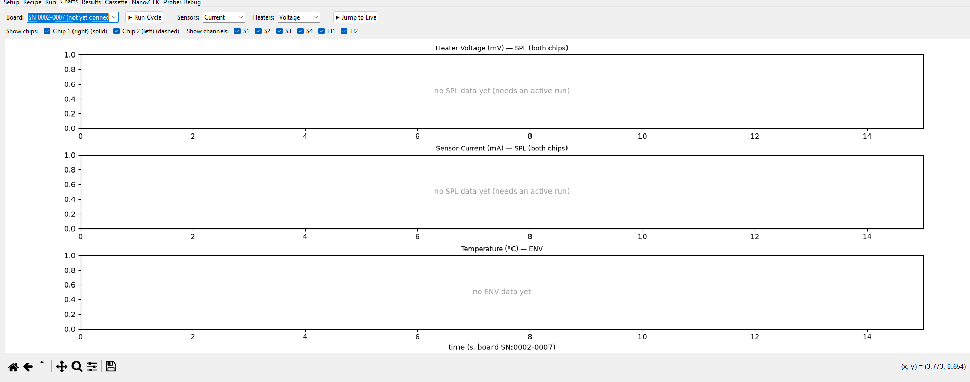
Live plots of a board’s readings over time — three stacked panels sharing a time axis: Heater Voltage (mV), Sensor Current (mA), and Temperature (°C). Pick Board (same picker as the Setup tab’s console), then ▶ Run Cycle to run a cycle on it directly from here. Sensors: and Heaters: switch what the sensor/heater panels are actually plotting (Current or Resistance for sensors; Voltage/Current/Power/Resistance for heaters). Show chips toggles Chip 1/Chip 2 (solid vs. dashed lines) on or off; Show channels toggles individual S1–S4/H1/H2 traces.
By default the view auto-scrolls to keep the most recent data on screen. Scroll to zoom the time axis, or use the navigation toolbar below the plot to pan/zoom manually — doing either drops out of auto-scroll (“browsing history” mode) so a live redraw doesn’t fight your pan/zoom mid-gesture; ▶ Jump to Live snaps back to the auto-scrolling view.

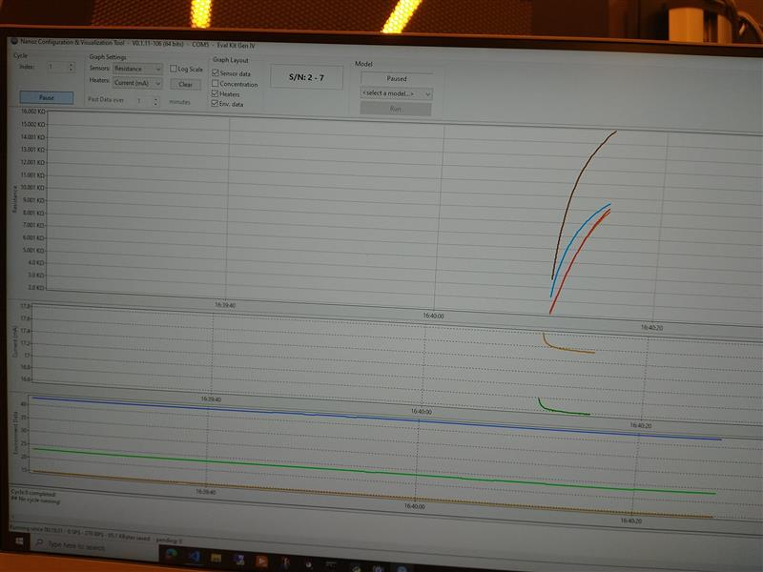
This is Nanoz_EK software charts, you can try and verify that the results here match my software.

Results
Lot ID / Wafer ID fields plus Export Path/Browse... at the top, then a live results table (port/chip/die/channel, V/I/R now and averaged, sample count, last-updated time) below.
For the time being, I have not created an export format for Nautilus. If you need, you will probably need to change code.
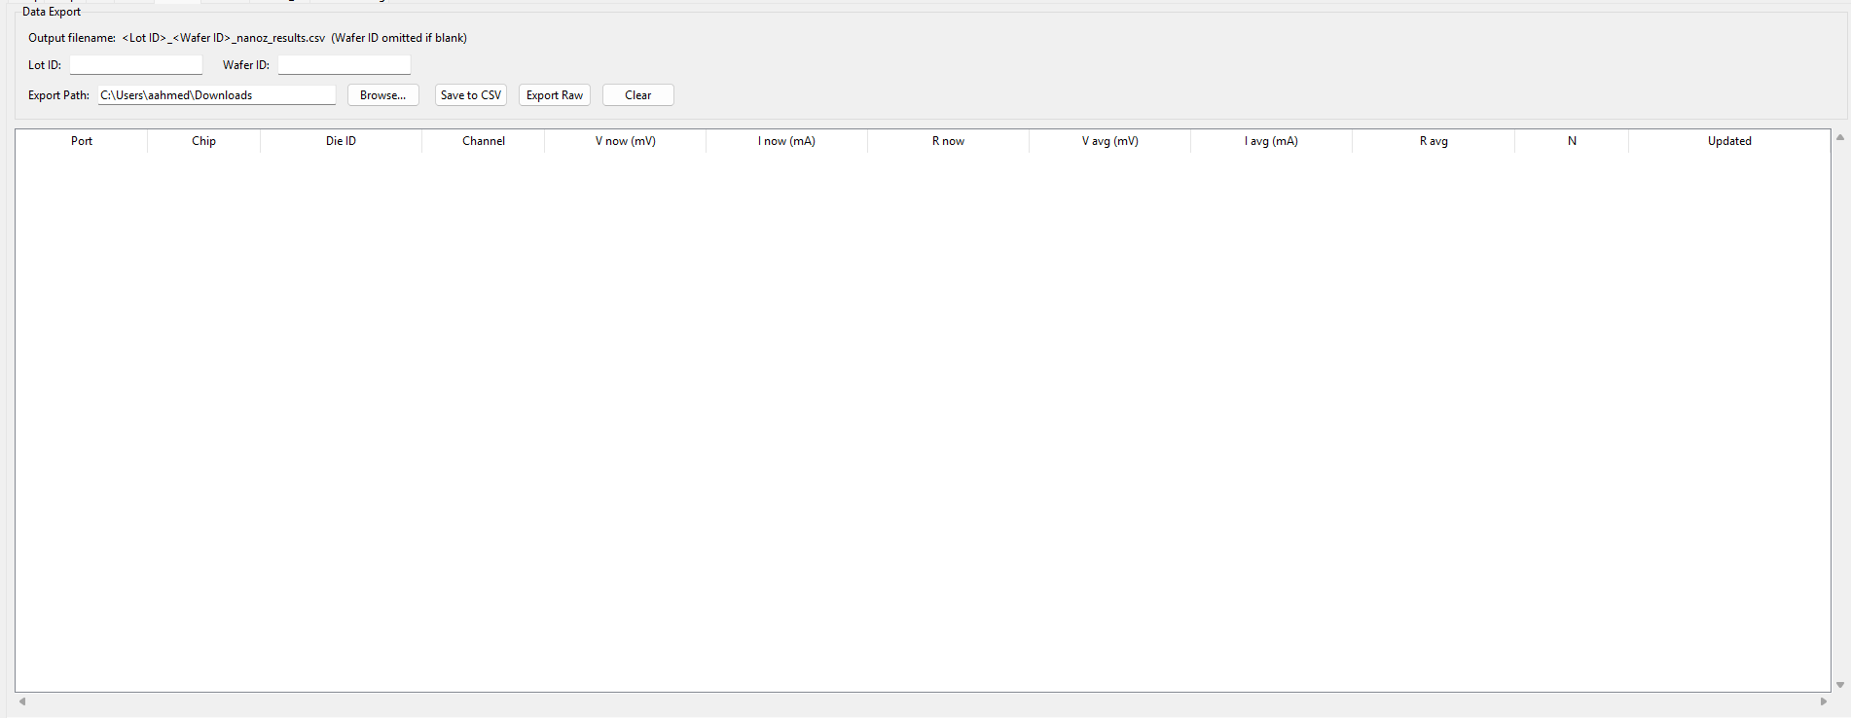

Export Raw Results
Export Raw writes out every individual sample taken — not the V/I averaged summary the results table shows, the underlying per-sample readings, each tagged with its die. Clear empties the current results (table and underlying data both) with no confirmation prompt, so export first if you still need what’s there.

Save Results CSV
Save to CSV writes the same kind of self-contained results CSV the normal (non-NanoZ) Results tab’s own button writes — the V/I/R summary per die/channel, not the raw per-sample data (see Export Raw Results, above, for that).

Cassette
Same as normal. Check Accretech side. No cassette for electroglas of course.
Note: not yet verified that it works with Nanoz recipes though.

NanoZ_EK
Direct read/write access to a board’s sequence configuration — cycle count, sequence timing, and heater parameters — as actually stored in its EEPROM, for setting up or inspecting a board’s programmed behavior below the level of a Recipe.
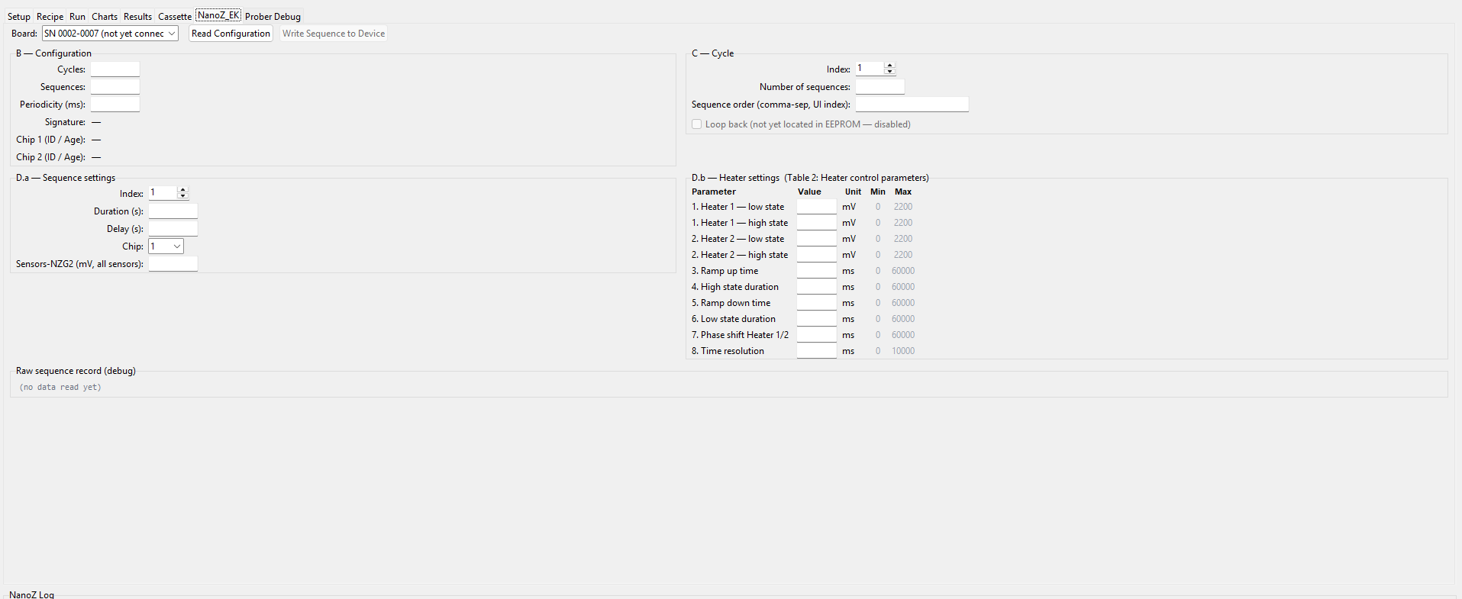

Sequence Read / Write
Pick Board, then Read Configuration to pull its current settings into the fields below (B — Configuration: Cycles/Sequences/Periodicity/Signature/Chip 1&2 ID-Age; C — Cycle: Index/Number of sequences/Sequence order; D.a — Sequence settings: Index/Duration/Delay/Chip/Sensors). Write Sequence to Device pushes edited D.a/D.b values back to the board — it stays disabled until a sequence has been read first, and only ever writes D.a/D.b (Chip/Resolution/Cycle/Configuration are left untouched).

EEPROM Access
Raw sequence record (debug), at the bottom, shows the raw data a read/write actually worked with — useful for confirming what’s really in EEPROM when a value shown elsewhere on the tab looks off. This is the same underlying access the Setup tab’s Board Console Read EEPROM control uses (see Discover / Connect / Disconnect Boards, earlier in this section), just surfaced here alongside the parsed configuration fields instead of as a standalone hex dump.

Heater / Sensor Fields
D.b — Heater settings (Table 2) lists every heater-control parameter as a row — heater 1/2 low and high state levels, ramp up/down times, high/low state durations, phase shift between the two heaters, and time resolution — each with its own Value field plus the driver’s documented Min/Max for that parameter. Sensors-NZG2 (mV, all sensors), in D.a, is where a sequence’s sensor readings show up alongside its timing settings.

NOTE: in general, don’t use this tab unless absolutely necessary. I recommend using the dedicated Nanoz_EK software given by client instead.

Prober Debug
(shared ProberDebugPanel/EgProberDebugPanel, same as the normal Debug tab)
Only used for chuck positioning, as usual. Can help with alignment for electroglas, try using the Theta jog functionality.

